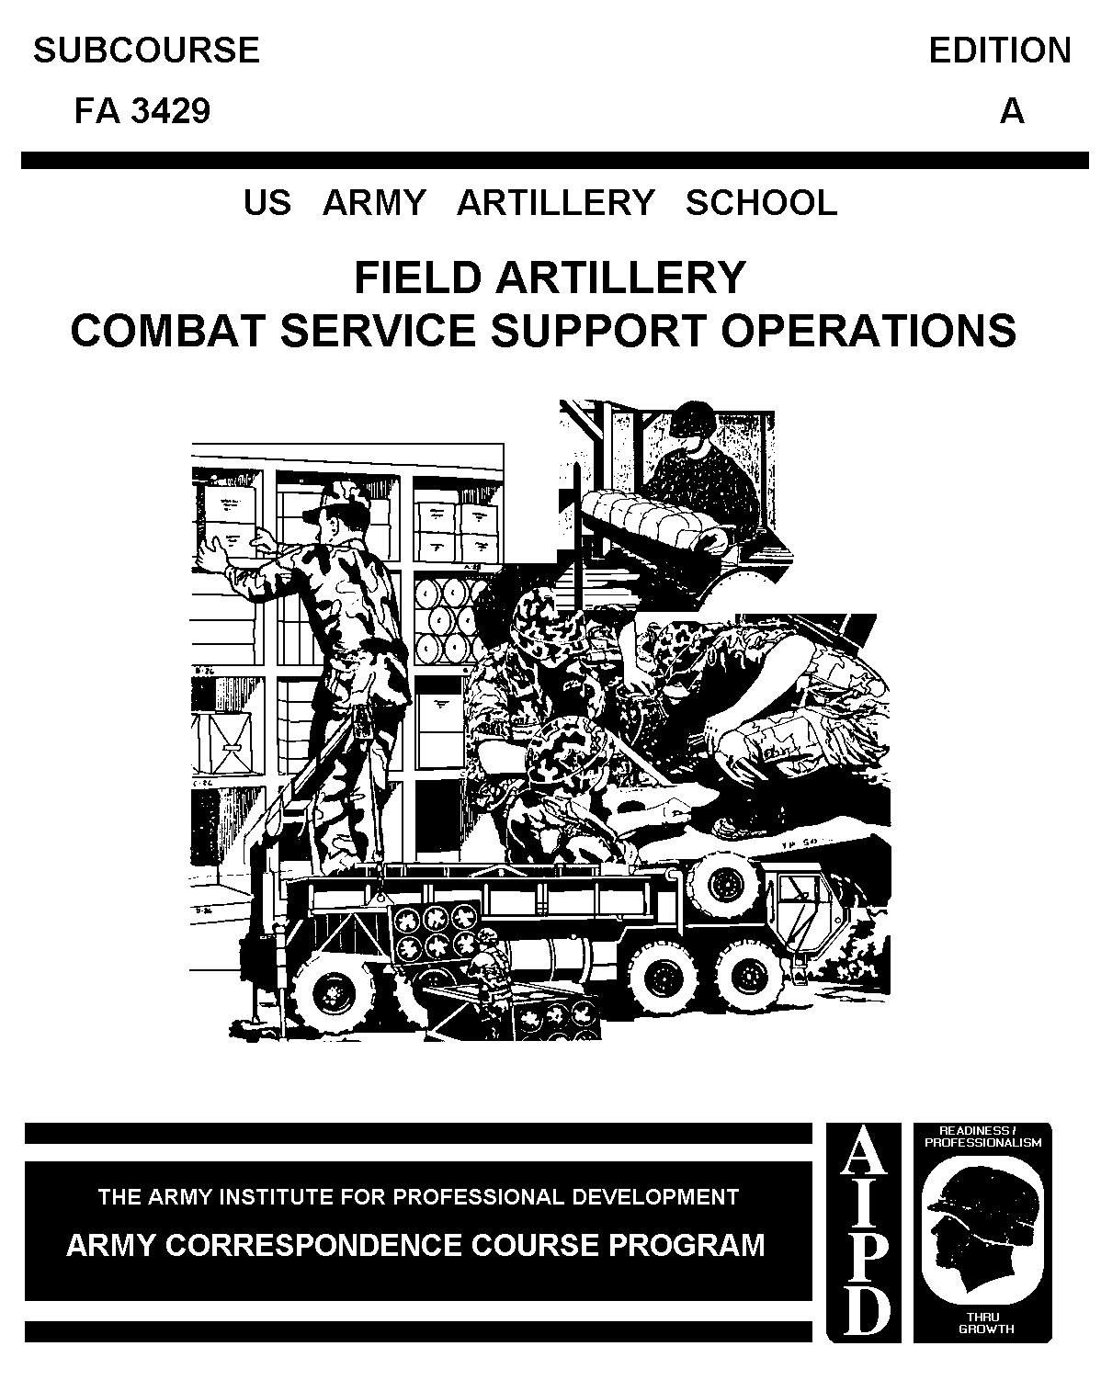

TABLE OF CONTENTS

Table of Contents i

Administrative Instructions iii

Subcourse Overview iv

Lesson 1: Combat Service Support Overview 1-1

Part A: DISCOM/COSCOM 1-2

Part B: The Heavy Division DISCOM 1-5

Part C: The Infantry Division (Light) DISCOM 1-9

Part D: Area Support Concept 1-13

Practice Exercise 1-19

Answer Key and Feedback 1-21

Lesson 2: Field Artillery Trains 2-1

Part A: Responsibilities 2-1

Part B: Brigade Trains 2-4

Part C: Battalion Trains 2-6

Part D: Determining Trains Organization 2-11

Part E: Trains Command and Control, Communications, and Security 2-12

Part F: Trains Positioning 2-14

Practice Exercise 2-17

Answer Key and Feedback 2-19

Lesson 3: Planning and Execution of Field Artillery Bn CSS Operations 3-1

Part A: Planning CSS Operations 3-1

Part B: Logistical Support 3-6

Part C: Classes of Supplies 3-9

Part D: Ammunition 3-13

Part E: Maintenance 3-15

Part F: Field Services 3-17

Part G: Personnel Services Support 3-18

Part H: Health Services Support 3-21

Part I: Reconstitution 3-22

Practice Exercise 3-25

Answer Key and Feedback 3-29

Appendix A: The Evolution of Ammunition Distribution A-1

Examination: E-1

Student inquiry sheet

ADMINISTRATION INSTRUCTIONS

Subcourse Content. This subcourse contains three lessons, each related to one or more field artillery Combat Service Support tasks An introduction presents an overall view of the subject.
Each lesson then explains how to perform each task.

Supplementary requirements. None.

Materials needed. You will need a number 2 pencil and paper (furnished by the student).

Supervisory assistance. There are no supervisory requirements for completion of this subcourse.

References. FM 6-20-1; TC 6-50; FM 63-2; FM 101-10-1/1; FM 100-10; and selected articles from the Military Review and Field Artillery Journal.

GRADING AND CERTIFICATION INSTRUCTIONS

Instructions to the student. This subcourse has an examination that is performance-based, multiple-choice test covering two lessons You must score a minimum of 75 percent on this test to meet the objectives of the subcourse.

Credit hours. Five credit hours will be awarded for successful completion of this subcourse.

* * * IMPORTANT NOTICE * * *
THE PASSING SCORE FOR ALL ACCP MATERIAL IS NOW 70%.
PLEASE DISREGARD ALL REFERENCES TO THE 75% REQUIREMENT.

FIELD ARTILLERY COMBAT SERVICE SUPPORT OPERATIONS.

Subcourse FA 3429

EDITION B

United States Army Field Artillery School
Fort Sill, Oklahoma 73503

Edition Date: Jan 1992
Credit hours: 5.
TASK NUMBER: 01-2840.00-2034

SUBCOURSE OVERVIEW

This subcourse will enhance your knowledge of field artillery battalion Combat Service Support (CSS) operations This text describes field artillery battalion trains concepts, duties of CSS personnel, and CSS operations.

This subcourse addresses current CSS doctrinal techniques as described in FM 6-20-1 and FM 6-50 It does not address all of the unique and unit/situational specific CSS techniques and procedures In your own work situation, always refer to the latest official publications.

Unless otherwise stated, the masculine gender of singular pronouns refers to both men and women.

TERMINAL LEARNING OBJECTIVE

ACTION: Identify how field artillery CSS operations are conducted, duties of key personnel, and how field artillery units interface with Combat Service Support (CSS) units at division and corps level.

CONDITION: Given the material contained in this subcourse.

STANDARD: To demonstrate competency in this task, you must achieve a minimum of 75% on the subcourse examination.

LESSON 1

COMBAT SERVICE SUPPORT OVERVIEW

OVERVIEW

LESSON DESCRIPTION:

This lesson will describe how the artillery interfaces with division and corps CSS units in both light and heavy TOE organizations.

LEARNING OBJECTIVE:

ACTION: Identify how artillery units interface with CSS organizations at corps and division level.

CONDITION: Given the material contained in this lesson.

STANDARD: Correctly answer all questions in the practice exercise at the end of this lesson.

REFERENCES: The material contained in this lesson was derived from the following publications: FM 6-20-1; TC 6-50; FM 63-2; Fm 101-10-1/1; FM 100-10; and selected articles from the Military Review and Field Artillery Journal.

INTRODUCTION

Desert Shield and Desert Storm demonstrate that the often mundane and detail-ridden world of combat service support is the very lifeblood of an army, especially an army called to deploy halfway around the world to a hostile environment. Further, these challenges must be met before combat power can be brought to bear and well after the dust of battle has cleared. In our future versatile, deployable, and lethal Army, logistics will play an even greater role. --Military Review, April 1991.

In the evolving concept of AirLand Operations, a major Army requirement is force projection. Force projection requires anticipatory and timely logistics operations--operations that rely on automated planning systems, modular replacement parts, and combat configured resupply loads. Future operations will be highly dynamic; i.e., artillery units will have to be more agile, self sustaining, and responsive than they are today.

PART A: DISCOM/COSCOM

Combat service support encompasses five functional areas: supply, movement, maintenance, services (such as bath and laundry), and miscellaneous related activities such as casualty evacuation and graves registration).

The operating principle of all combat service support is to provide support forward. Combat service support units function near the using units they provide support to. Commanders at all levels are responsible for the combat service support of all organic, assigned, and attached units.

Where do field artillery units get their logistical support? Artillery unit support relationships change, depending upon the type of artillery unit involved, (corps vs. divisional), weapon system (tube vs. rocket/missile), and assigned artillery mission (direct support, general support, reinforcing, or general support reinforcing).

The Division Support Command (DISCOM) provides most of the direct logistics support to divisional artillery units. Corps artillery units usually receive their logistic support directly from the Corps Support Command (COSCOM).

1. COSCOM.

The COSCOM provides support to corps organic and attached units. COSCOM, when directed, will support forces of other services or countries. Corps CSS units operate as far forward as necessary to support the tactical units in their assigned area.

COSCOM headquarters, with its material management and movement control centers, sets up shop in the corps rear area. The corps headquarters and COSCOM headquarters should be within reasonable distance of each other because of their close relationship.

Corps support groups (CSGs) provide the command and control of the COSCOM's logistics units. One corps support group will normally support each committed division, and one will support the corps rear. Each CSG will have a mix of general support (GS) and direct support (DS) resources. CSG direct support units support forward nondivisional organizations, i.e., corps artillery units, and provide added support to divisional units. Each CSG is multifunctional--CSGs have supply, service, and direct support maintenance units.

Under control of the movement control center (MCC), corps transportation units move ammunition, replacement equipment, personnel, and other supplies from GS units to COSCOM and division direct support units (DSUs).

COSCOM's medical brigade treatment facilities treat patients evacuated from forward units. These facilities hold patients who can return to duty within times specified by evacuation policy. Patients requiring longer recovery times are evacuated to communications zone (COMMZ) hospitals. The treatment facilities also provide unit-level support in their assigned areas.

Corps units provide personnel and administrative services, finance support, aviation CSS, and civil military operations (CMO) support in the corps rear area. The COSCOM provides supply services, maintenance, transportation, and health services in the corps rear area.

NOTE: Corps general support artillery units usually rely directly on the COSCOM CSGs for support. If corps artillery units are assigned a general support reinforcing mission in support of a division, they may, with extensive coordination, draw the bulk of their logistics support from their supported division's DISCOM. Upon a change of mission, corps artillery units adjust their logistical support relationships. Habitual CSS support relationships for corp artillery units are rare; these artillery units "coordinate relentlessly" for their support.

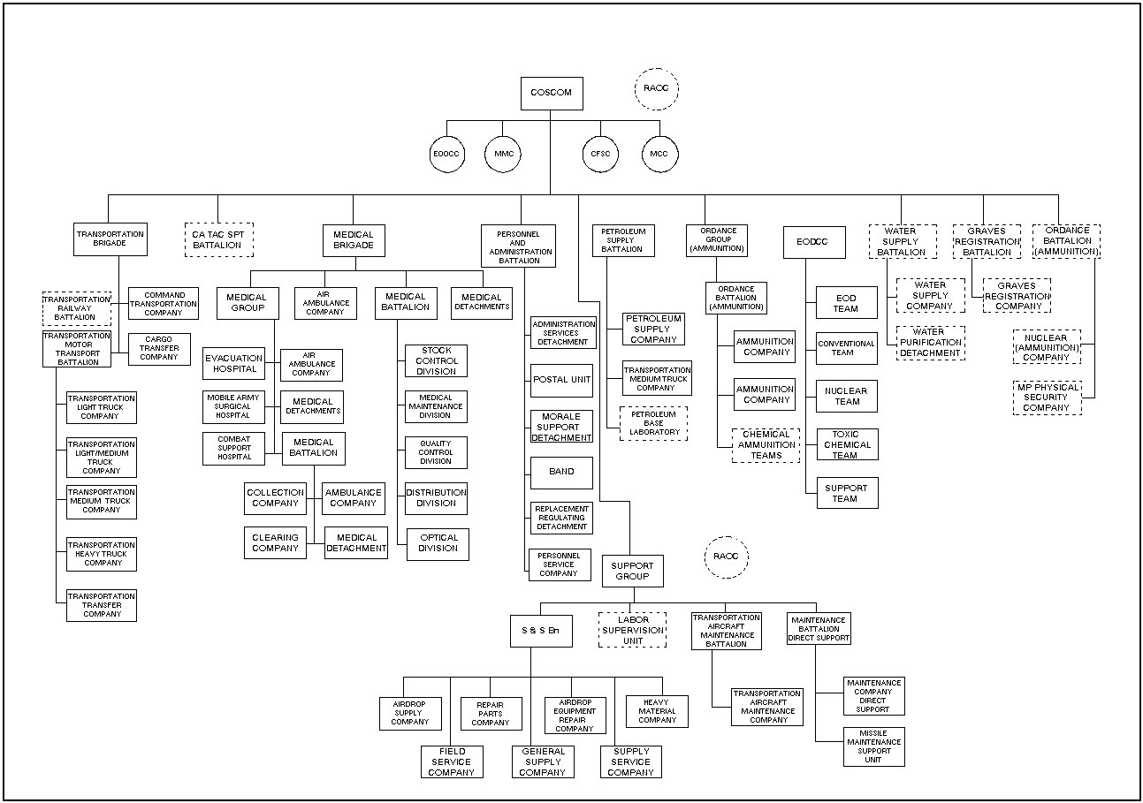

Figure 1-1. Type Corps Support Command (COSCOM).

2. DISCOM.

The DISCOM provides direct support logistics to all divisional organic, assigned, and attached units. The DISCOM, unlike the COSCOM, has a fixed structure to support all organic, assigned and attached units.

PART B: THE HEAVY DIVISION DISCOM.

In a heavy division, the DISCOM has two companies and four battalions (Figure 1-2). A Headquarters and Headquarters Company provides command and control to the DISCOM. The key element in the HHC is the Division Material Management Center, (DMMC) (Figure 1-3) the focal point for logistics operations within the division. The DMMC provides division units with centralized and integrated material management for class I, II, III, IV, V, VII, and IX supplies and maintenance. The aviation intermediate maintenance company (AVIM) provides maintenance support to the division's aviation units. Some division's have an aviation forward support battalion which provides aviation and ground maintenance support and services to the divisional brigade. The Main Support Battalion (MSB) provides logistic support to units operating outside of the brigade sectors (other than aviation units), and supports the Forward Support Battalions (FSBs) operating in the brigade sectors.

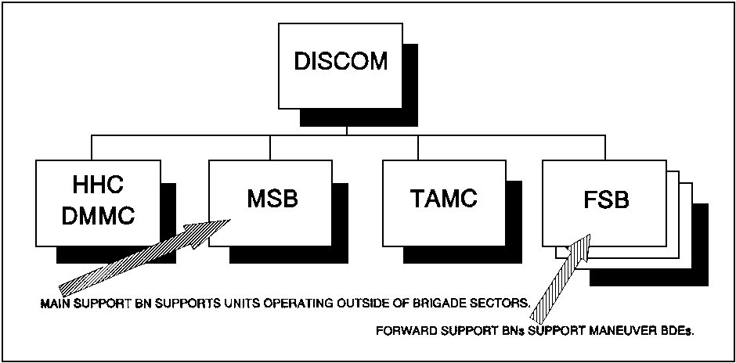

Figure 1-2. The Heavy Division DISCOM.

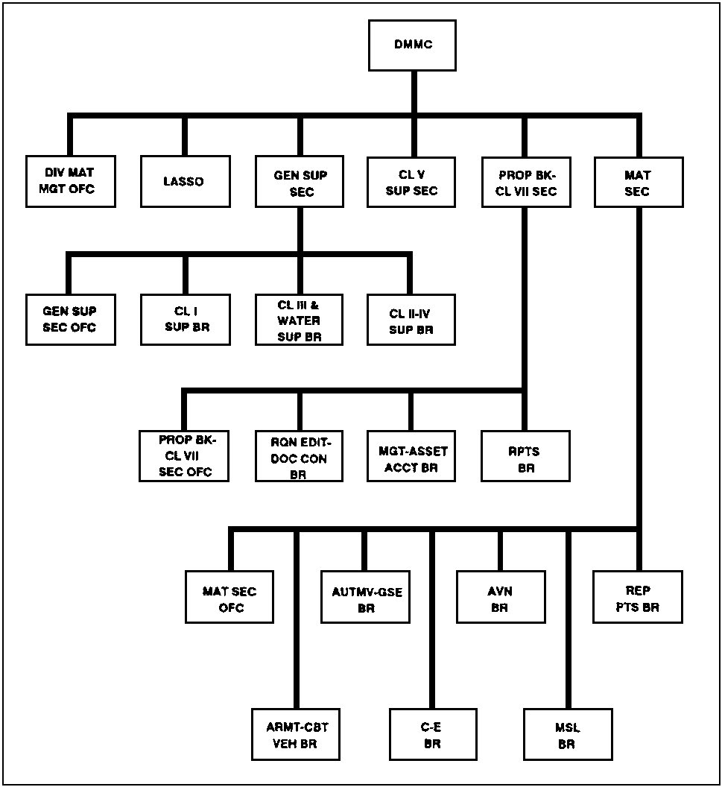

Figure 1-3. The DMMC.

1. The Main Support Battalion.

The Main Support Battalion contains the companies shown in Figure 1-4. Divisional artillery units such as the divarty HHB, TAB, and MLRS batteries receive most of their CSS support from the Main Support Battalion. The Main Support Battalion provides maintenance and repair services for much of the division's complicated technical material; such as, gyros, fire control equipment, and electronic systems. Main Support Battalion units and their critical functions are:

- The Medical Company, in addition to caring for the wounded, operates the division medical facility. The company provides emergency and preventive dental care, psychiatric treatment, mental health consultation, and division level medical resupply to division and nondivisional units. Additionally, the MSB medical company issues medical supplies and handles the evacuation of casualties.

- A Supply and Service Company provides three key services: water purification and issue point, a laundry and bath facility, and the divisional issue point for supply classes I, II, III, IV, V, VI, VII and IX.

- A Transportation Motor Transport Company provides transportation support for the division.

- The Heavy Maintenance Company repairs tracked vehicles and associated armaments, communications, and engineer equipment.

- The Light Maintenance Company repairs wheeled vehicles and associated armaments, communications, and engineer equipment.

- The Missile Maintenance Company provides repair services to the units having missiles, including TOW, STINGER, and CHAPARRAL.

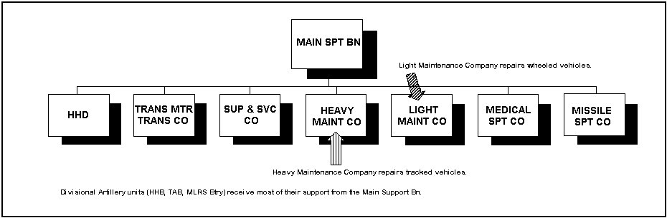

Figure 1-4. The Main Support Battalion (MSB).

2. Forward Support Battalion.

The DISCOM has three Forward Support Battalions (FSBs), each commanded by a lieutenant colonel, which habitually support the three maneuver brigades within the division. This habitual support includes support to each brigade's DS artillery battalion. The FSB provides all classes of logistic support to the units operating in the brigade sector. FSBs have:

- A Supply and Services Company that operates the supply point for the brigade and the ammunition transfer point (ATP), for forward distribution of ammunition.

- A Maintenance Company which provides maintenance support to the brigade. Two key elements within the maintenance company are the support teams. The number of teams vary based on the composition of the brigade itself (tank heavy versus mechanized infantry heavy). The Maintenance Company's Armament Shop can repair Field Artillery systems.

- A Medical Company that provides medical support to the brigade. This unit provides medical supplies to the medics in the line battalions and casualty evacuation. The FSB Medical Company provides the same type of care an MSB Medical Company provides.

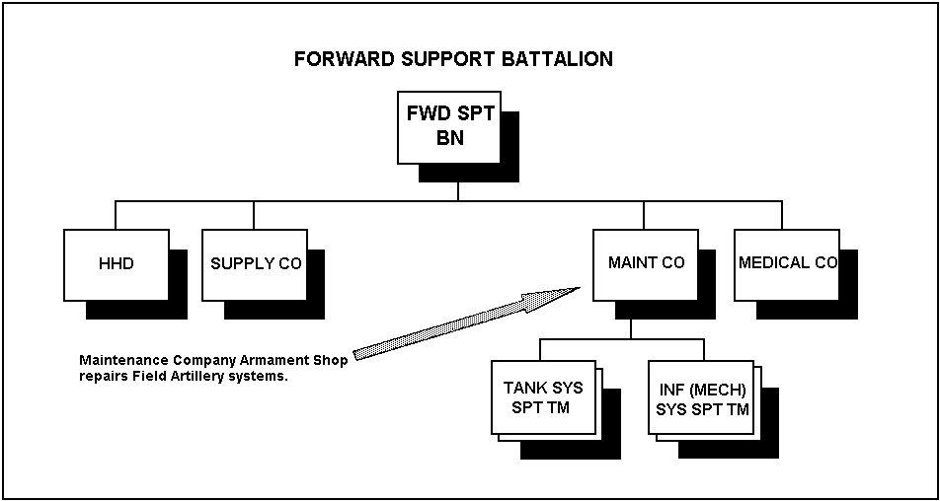

Figure 1-5. The Forward Support Battalion (FSB).

PART C: THE INFANTRY DIVISION (LIGHT) DISCOM.

The organization of the DISCOM in the light infantry division is quite different from that in the mechanized divisions. The light infantry division DISCOM contains a Headquarters and Headquarters Company, a Medical Battalion, Supply and Transport Battalion, Maintenance Battalion and an Aircraft Maintenance Company.

NOTE: In airborne and air assault divisions, the aircraft maintenance unit is a battalion-size organization.

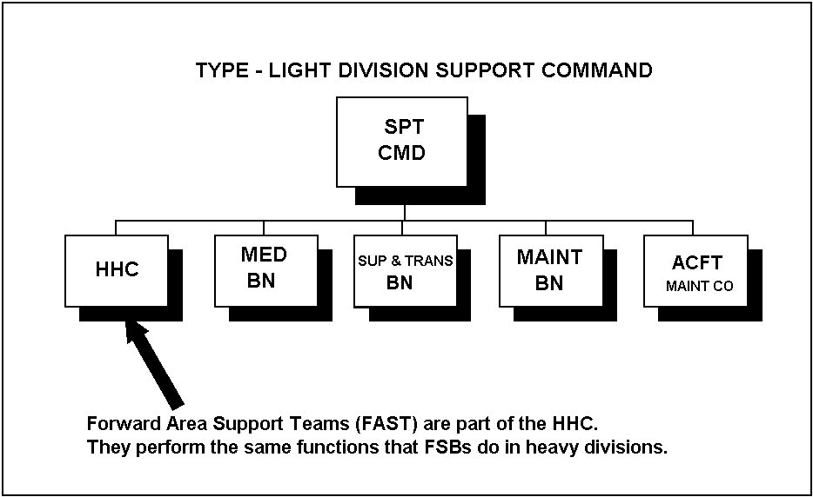

Figure 1-6. Type Light Division Support Command (DISCOM).

1. Headquarters and Headquarters Company.

Among the functions found in the headquarters company are:

- Forward Area Support Coordinators (FASCO). FASCOs are responsible for the interface between the logistic unit supporting a brigade, the FAST (Forward Area Support Team) located in the BSA, and the supported force. FASTs perform the same functions that FSBs do in heavy divisions.

- The division ammunition officer. This officer represents the DISCOM commander in matters pertaining to ammunition requirements and availability. The DAO assists the division G3 and G4 in establishing the Required Supply Rate (RSR) or forecasted ammunition requirements determined by personal experience, historical records, or FM 101-10-1 Staff Officers' Field Manual.

2. Medical Battalion.

The Medical Battalion provides division-wide health support. The battalion accomplishes its mission with the four companies shown in Figure 1-7.

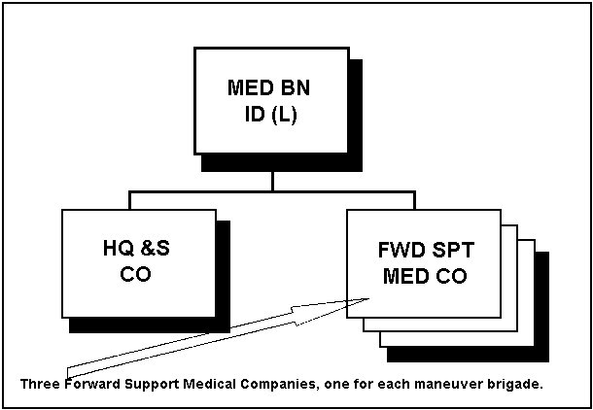

Figure 1-7. Medical Battalion.

- The Headquarters and Support Company, located in the division rear area, provides support to the whole division. It commands and controls medical support to the battalion, and operates medical resupply and equipment repair services. The Headquarters and Support Company also evacuates wounded personnel, and provides division-wide support in preventive medicine, mental health, and optometry services.

- Three Forward Support Medical Companies, one in each brigade rear area, provide Class VIII resupply services. They also provide health care for the wounded, and casualty evacuation to line units operating in the brigade area.

3. Supply and Transportation Battalion.

The Supply and Transportation Battalion contains five companies to support the brigades and the division. The companies and critical functions are:

- Headquarters and Supply Company. This company, which includes the battalion headquarters, provides water supply and distribution, property book accountability for divisional units, and the following classes of supply:

Class I (rations)

Class III (POL)

Class IV (construction material)

Class VII (major end items)

- Transportation Motor Transport Company. This company contains the ground transportation for distribution of supplies and equipment. Additionally, it supports divisional units in their movement.

- Forward Supply Companies. These companies operate in brigade rear areas to provide distribution of Class I, II, III, IV, and VII supplies. Additionally, they operate the ammunition transfer point in the brigade rear area.

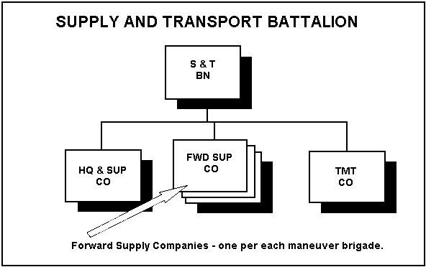

Figure 1-8. Supply and Transportation Battalion.

4. Maintenance Battalion.

A Maintenance Battalion has a Headquarters and Light Maintenance Company and a Main Support Company. The Headquarters and Light Maintenance Company manages Class IX (repair parts) and repairs electronic equipment within the division. The Maintenance (Main) Support Company provides parts exchange services for selected items of equipment, and repairs artillery fire control equipment. A platoon from the company is placed forward with the Forward Support Company.

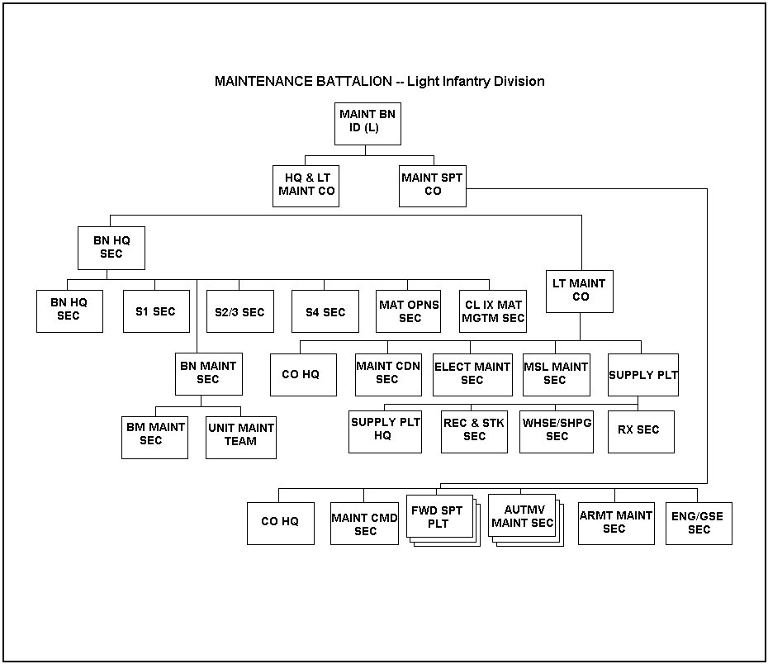

Figure 1-9. Maintenance Battalion.

5. Aircraft Maintenance Company.

The Aircraft Maintenance Company provides maintenance support to the division's aircraft.

PART D: AREA SUPPORT CONCEPT

Logistics support multiplies and sustains combat power. To do this the Combat Service Support system provides support on an area basis. Units operating in a particular area derive their support from the logistical agency servicing that area. For example, a FA battalion in direct support of a brigade will draw its CSS from the CSS unit assigned the mission of supporting that brigade.

1. Brigade Support Area.

Within each committed maneuver brigade sector there will be a brigade support area (BSA). The BSA houses most of the logistic support assets for the entire brigade, including the logistics elements of the direct support artillery battalion. The BSA contains the brigade trains, a FSB (or FAST), and some DISCOM and COSCOM elements (ammunition, POL, etc.,). The brigade S4 supervises the activity in the BSA. Normally positioned 20-25 km from the FLOT, the BSA usually contains the logistics trains of the maneuver battalions that the BSA supports.

The FSB commander, is responsible for DISCOM elements in the BSA, he is responsible to both the DISCOM commander and the commander of the maneuver brigade which the FSB habitually supports. He works with the maneuver brigade commander and his staff to provide the brigade its support. Recall that in light divisions a FAST instead of a FSB is used. In light divisions the FAST's forward area support coordinator (FASCO), is responsible for DISCOM elements in the BSA (Figure 1-10).

The BSA houses all types of support for the brigade operating in the brigade area. Services such as graves registration, clothing exchange, and bath facilities (shower points) are provided by division, and in some cases, corps logistics units.

2. Division Support Area.

The Division Support Area (DSA) contains the division trains which provides overall support to the division. It is normally a consolidated group of CSS elements located in the division rear. The DSA contains the division level support facilities of the DISCOM, any COSCOM elements operating there, and the battalion trains of any units located in the division rear (Figure 1-11).

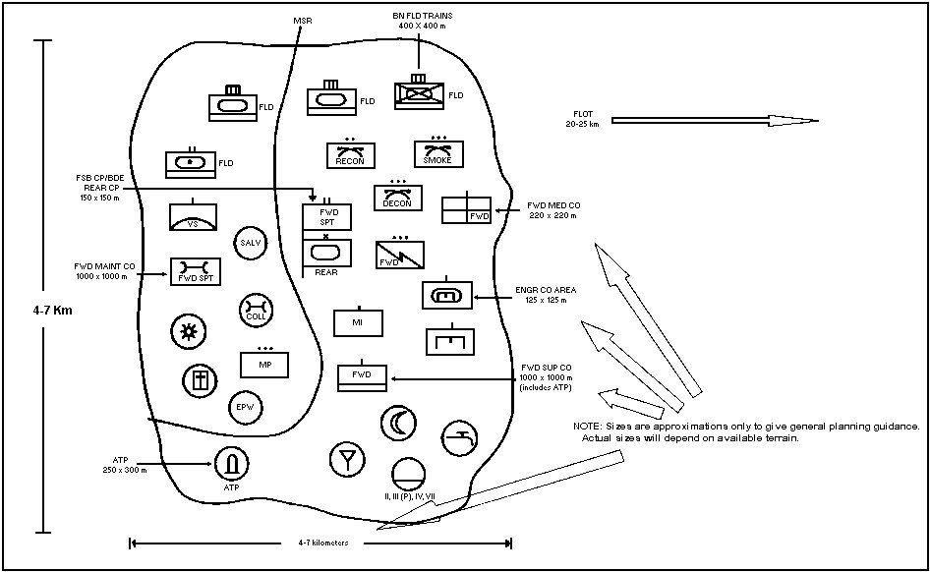

Figure 1-10. Sample BSA layout (division elements).

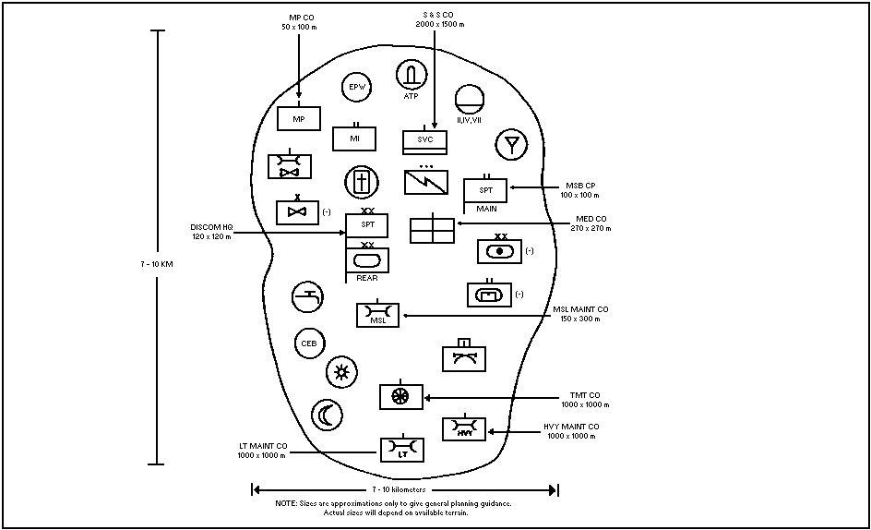

Figure 1-11. Sample DSA layout (division elements).

3. Corps Support Area.

The Corps Support Area (CSA) is normally located in the corps rear, but in some instances may be in the division rear. The number of CSAs set up by a corps depends on the factors of METT-T. Normally, a corps will establish one CSA in the corps rear and one CSA for each committed division.

Divisional and nondivisional units not supported by CSS units in a BSA must return to the Division Support Area (DSA) or Corps Support Area (CSA) respectively, for their CSS. There is a significant advantage for a unit to draw its support from the BSA (normally located only 20-25 km from the FLOT). Turnaround time for needed support is shortened because of the short true distance involved. FA units other than the DS battalion operating in the brigade sector may, with advance coordination, draw their CSS from the BSA. This support will depend on the capabilities of the DISCOM and COSCOM units located there.

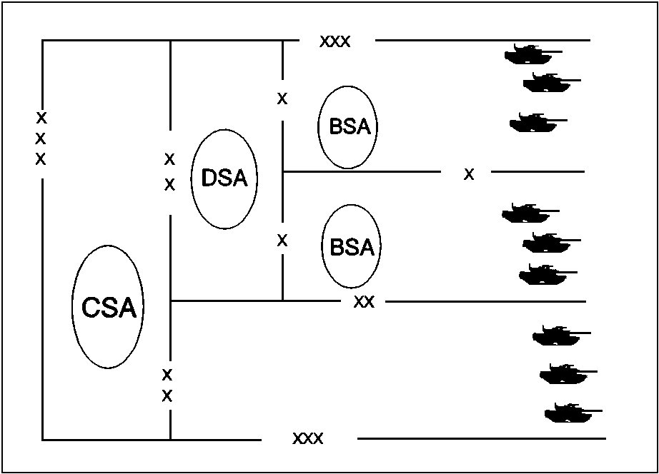

Figure 1-12. CSA, DSA, BSA.

4. Artillery battalion level support assets.

Headquarters, service, and the firing batteries of a FA battalion all have their own CSS assets. CSS assets organic to field artillery battalions and their batteries vary based on the type of battalion, for example, divisional versus nondivisional units. Various organic CSS assets to the firing batteries are:

- Nondivisional and 3 x 6 FA battalions (usually reserve component units) still retain significant organic combat service support assets in their firing batteries. Battery level CSS assets may consist of maintenance, mess, supply, and ammunition.

- In heavy divisions, most of the CSS elements within the FA battalion are in the headquarters and service batteries. CSS elements in a headquarters battery include the personnel administration center, medical section, and battalion mess. Service battery elements include the battalion supply section, maintenance section, and the ammunition platoon. Individual batteries rely upon the battalion to provide most of their CSS needs. Normally, the battalion will send contact teams to the firing batteries to provide the necessary combat service support based on the factors of METT-T (mission, enemy, terrain, troops, and time available).

NOTE: In airborne and air assault divisions, the battalion CSS assets are found in a combined Headquarters and Service Battery.

To facilitate flexible, responsive service support on the battlefield, the battalion commander, considering METT-T, may centralize battery combat service support assets under battalion control. By consolidating assets at battalion level, battery commanders can concentrate on their primary mission--providing field artillery support.

The centralization may include supply, mess, maintenance and ammunition under the supervision of the battalion S4. Cooks and mess operations may be consolidated under the control of
the service battery commander or S4. Ammunition resupply and stockage operations are
consolidated under the control of the BAO (Battalion Ammunition Officer). The battalion's maintenance personnel and equipment are consolidated under the control of the BMO (Battalion
Maintenance Officer). Using this concept, contact teams provide responsive support to the
firing batteries. The battalion commander would have the option of placing the greatest degree of
support with the battery most needing it. A more detailed explanation of the who, how, where, and why of field

artillery battalion CSS operations is the subject of the next lesson.

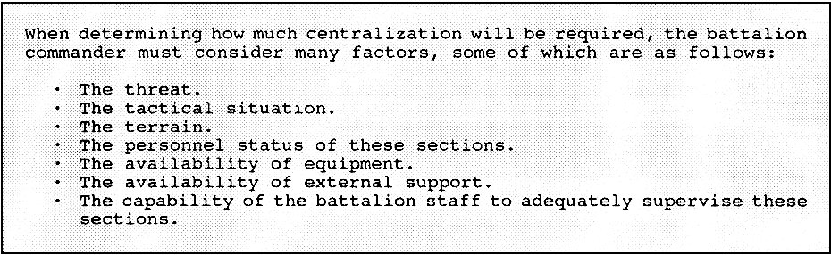

Figure 1-13. Centralization.

THIS PAGE IS INTENTIONALLY LEFT BLANK

LESSON 1

PRACTICE EXERCISE

The following items will test your knowledge of the material covered in this lesson. There is only one correct answer for each item. When you complete the exercise, check your answer with the answer key that follows. If you answer any item incorrectly, study again that part of the lesson which contains the portion involved.

1. ________________ is the operating principle of all combat service support.

A. Use of only what is needed
B. Building up consumer demand
C. Providing forward support
D. Real time information processing

2. T F The Direct Support Logistics Command provides most of the logistics support to divisional artillery units.

3. Corps artillery units, when assigned a general support reinforcing mission in support of a division, may draw the bulk of their logistic support from the _______________.

A. Supported Division Log Center
B. Supported Division's DISCOM
C. Division Support Groups
D. Brigade Support Area

4. T F The DMMC is the focal point for logistics operations within the division.

5. T F The area support group provides logistics support to units operating outside of the brigade sectors.

6. Artillerymen may get their water, bath, and laundry services from the:

A. Supply and Service Company in the Main Support Battalion.
B. Supply and Service Battalion in the DISCOM.
C. Water and Bath, and Laundry Battalion in the DISCOM.
D. Water, Bath, and Laundry Company in the Main Support Battalion.

7. T F DS artillery units, in heavy divisions, get the bulk of their support from a forward support battalion.

8. In light divisions, the DISCOM does not have a:

A. Forward Support Bn.
B. Medical Bn.
C. Supply and Transport Bn.
D. Headquarters and Headquarters Co.

9. T F DS artillery units in light divisions receive their support from a forward support battalion.

10. T F A target acquisition battery in a heavy division, usually receives its support from a Main Support Battalion.

11. T F In a light division, the Main Support Company repairs artillery fire control equipment.

12. The Forward Support Battalion operates in the _______________ area.

A. Division Support.
B. Brigade Support.
C. Corps Support.
D. Forward Support.

13. T F GS artillery units may draw their support from the forward support Bn operating in the Brigade Support Area if they coordinate in advance.

14. In heavy divisions, most of the DS FA battalion's CSS elements are found in ______________.

A. all the firing batteries.
B. all the batteries.
C. service battery only.
D. headquarters and service batteries.

15. An advantage of centralizing CSS assets under battalion control is:

A. tighter management control of limited resources.
B. greater flexibility for forward support CSS operations.
C. battery commanders are free to concentrate on fire support tasks.
D. standardization across the battalion in providing CSS.

LESSON 1

PRACTICE EXERCISE

ANSWER KEY AND FEEDBACK

Item Correct Answer and Feedback

1. C. Providing forward support

The operating principle of all combat service support is to provide support forward. (Page 1-2, Part A.)

2. F

The support agency which provides most of the direct logistics support to divisional artillery units is the Division Support Command (DISCOM). (Page 1-2, Part A.)

3. B. Supported Divisions DISCOM

If Corps Artillery units are assigned a general support reinforcing mission in support of a division . . . (Page 1-3, Part A, para 1, NOTE.)

4. T

The key element in the HHC is the Division Material Management Center. . . the focal point for logistics operations within the division. (Page 1-5, Part B.)

5. F

The Main Support Battalion (MSB) provides logistic support to units operating outside of the brigade sectors and supports the Forward Support Battalions (FSBs). . . (Page 1-5, Part B.)

6. A. Supply and Service Company in the Main Support Battalion.

A Supply and Service Company provides two key services available to field artillerymen, the water point and the bath and laundry facility. (Page 1-7, Part B.)

7. T

The DISCOM is organized with three Forward Support Battalions (FSBs), each commanded by a lieutenant colonel. (Page 1-8, para 2.)

8. A. Forward Support Bn.

Recall that in light divisions the FAST instead of a FSB is used. . .(Page 1-13, Part D, para 1.)

9. F

The Forward Area Support Coordinators (FASCO). . . the FAST (Forward Area Support Team) Team located in the BSA, and the supported force. . . (Page 1-9 & 1-10, Part C, para 1.)

10. T

The Main Support Battalion (MSB) contains . . . (Page 1-7, Part B, para 1.)

11. T

A Maintenance Battalion is organized with a headquarters and Light Maintenance Company and a Main Support Company. (Page 1-12, Part C, para 4.)

12. B. Brigade Support

The BSA contains the brigade trains, an FSB (or FAST), and some DISCOM and COSCOM elements. . . (Page 1-13, Part D, para 1.)

13. T

FA units other than the DS battalion operating in the brigade sector may, with advance coordination, draw their CSS from the BSA. . . (Page 1-15, Part D, para 3.)

14. D. Headquarters and Service battery.

In heavy divisions most of the CSS elements within the FA battalion are in . . . (Page 1-16, Part D, para 4.)

15. C. battery commanders are free to concentrate on fire support tasks.

By consolidating assets at battalion level, battery commanders are free to concentrate their efforts on performing their primary mission—providing field artillery support. (Page 1-16, Part D, para 4.)

THIS PAGE IS INTENTIONALLY LEFT BLANK

LESSON 2

FIELD ARTILLERY TRAINS

OVERVIEW

LESSON DESCRIPTION:

This lesson discusses the duties and responsibilities of key field artillery battalion personnel involved in CSS operations. It also provides a detailed description of the field artillery trains concepts used by commanders to facilitate CSS operations.

LEARNING OBJECTIVE:

ACTION: Identify the duties of key personnel in conducting CSS operations, and the reasons for using a single or dual trains concept.

CONDITION: Given the material contained in this lesson.

STANDARD: Correctly answer all questions in the practice exercise at the end of this lesson.

REFERENCES: The material contained in this lesson was derived from the following publications: FM 6-20-1; TC 6-50; TC 6-60; and selected articles from the Field Artillery Journal.

INTRODUCTION

Combat service support is a critical but often neglected component of war-fighting. If artillery battalions are to provide sustained fire support to maneuver units, they must be resupplied with food, fuel, and ammunition; wounded soldiers must be cared for and evacuated; personnel and equipment lost in combat must be replaced; and equipment must be maintained. A shortfall in any of these areas can quickly render a unit combat ineffective. This lesson outlines the organizations within the FA battalion that are tasked to provide CSS.

PART A: RESPONSIBILITIES

To the maximum extent possible, the responsibility for CSS operations has been removed from the firing battery commander and given to the battalion commander. The battery commander can then concentrate on the timely and accurate execution of the fire support mission. The CSS responsibility at battery or platoon level is to report requirements, request support, and ensure that resources are properly used once they arrive in the unit area.

1. Battalion XO.

As the maneuver commander's fire support coordinator, the FA battalion commander will be forward with supported maneuver units. The artillery battalion executive officer (XO) is responsible for coordinating all CSS within the battalion. While the battalion XO is responsible for CSS, he is also the battalion second in command (2IC). He will delegate many CSS responsibilities to the S1, S4, and BMO, as well as the Service and HHB commanders. During the battle, the S3 functions as the OIC of the tactical operations center (TOC). This allows the battalion XO the flexibility to move to critical points requiring his CSS expertise.

2. The S1 Section.

The S1 section is responsible for personnel services and the general administration of the battalion. He is assisted by the personnel and administration center (PAC) supervisor and the personnel staff NCO (PSNCO). The S1 and his staff perform the critical tasks of strength accountability, casualty reporting, replacement operations, administrative services, personnel actions, legal services, finance services, and command post functions. The S1 is also responsible for enemy prisoner of war (EPW) operations and medical planning. He coordinates with the S2 for interrogation of prisoners and with the S4 for processing of captured equipment and transportation requirements. The S1 coordinates with the medical section leader to ensure that patient treatment and evacuation are planned and coordinated throughout the battalion area.

3. The S2 Section.

The battalion S2 assists the S3 in positioning CSS assets, such as the combat trains and the unit maintenance collection point (UMCP). He considers enemy indirect fire assets, as well as avenues of approach into the brigade area of operations. The S2 provides threat overlays to these elements and monitors the positions proposed to support the scheme of maneuver. The S2 is responsible for distributing maps as required. Classified maps are obtained through G2 or S2 channels. Based on counterfire communication links, the S2 may also be tasked to monitor the logistical status of attached radars.

4. The S3 Section.

The battalion S3 considers the logistical implications of the tactical plan, and forecasts all logistical requirements. He ensures that CSS planners and operators are consulted early in the planning process and that they are kept informed as the plan is developed and executed. He coordinates land use for battalion CSS units and, in conjunction with the S4, recommends to the

battalion commander priorities for subordinate elements when resources are constrained.

5. The S4 Section.

The S4 is responsible for the logistical support of the battalion and for the preparation of paragraph 4 of the FA support plan. This section is responsible for supply, transportation, and field service functions. It coordinates requisition and distribution of supplies to battery supply sections and turns in captured supplies and equipment as directed. Personnel in the S4 and S1 sections are cross-trained in critical tasks to facilitate continuous operations.

In combat, the S4 concentrates on seven classes of supply: I, II, III, IV, V, VII, and IX. The battalion ammunition officer, working with the S3 and S4, coordinates the requisition, receipt, preparation, and delivery of Class V.

The S4 section obtains water and maps. Battalion transportation obtains water from the supply point in or near the BSA, or from forward sources tested and approved by the medical section noncommissioned officer in charge (NCOIC). Maps are stocked by the supply and service company of the main support battalion; they are requested through the supply company of the forward support battalion (FSB).

6. The Battalion Maintenance Section.

Maintenance operations are executed as far forward as feasible. The battalion maintenance section is responsible for unit maintenance on all battalion equipment except medical equipment. The OIC is the battalion maintenance officer, who is assisted by the maintenance technician and the senior maintenance supervisor.

Some TOEs have consolidated maintenance activities, however, the responsibility for operator and crew maintenance remains with the battery commanders. During maintenance operations, the maintenance elements of the battalion are task-organized to maximize forward support to the batteries.

The administration section maintains either automated or manual Class IX (repair parts) and the Army Maintenance Management System (TAMMS) records. The Prescribed Load List (PLL) stocks are maintained for each battery and are managed by unit PLL clerks, located with the appropriate battery maintenance team.

The recovery section provides recovery and lift capability to the battalion maintenance section as well as to each firing battery. Recovery assets may be positioned to facilitate repairs and the movement of major assemblies and components as needed.

7. The Battalion Medical Section.

The battalion aid station (BAS) sorts, treats, and evacuates casualties or returns them to duty. It stocks medical supplies for the battalion and manages all Class VIII support. It is also responsible for maintaining and evacuating battalion medical equipment.

The medical section (treatment team) officer in charge (OIC), a field surgeon, or a physician's assistant operates the battalion aid station. He coordinates the operations, administration, and logistics of the medical section, to include coordination of patient evacuation to supporting medical facilities and provision of medical support to the batteries.

8. The Battalion Ammunition Section.

The battalion ammunition section is an element of the service battery (or headquarters and service battery in light units). It is supervised by, and receives orders from, the battalion ammunition officer. He performs the ammunition resupply functions for the battalion. Usually, battery ammunition sections are consolidated under battalion control.

9. Battery Responsibilities.

Each battery in the battalion has a limited CSS capability. Normally, a battery headquarters has its own supply and communications sections. Because of operational considerations, some or all of these elements may have to be centralized at battalion level, as discussed in Lesson One.

NOTE: The battery first sergeant of the firing unit coordinates and directs the activities of the supply sergeant, who is the primary executor of battery logistic functions.

PART B: BRIGADE TRAINS

To understand how the artillery battalion organizes its CSS elements to support combat operations, it is necessary to understand the brigade trains concept. The brigade trains are located in the BSA about 20 to 25 kilometers behind the FLOT, beyond the range of most enemy cannon artillery.

A brigade does not have organic CSS elements to support battalions under its control. CSS assets in the BSA include elements from the FSB and/or forward area support team (FAST), maneuver and combat support unit field trains, and selected corps support command (COSCOM) and division support command (DISCOM) resources, as required. Normally, BSA support consists of the following:

- A Class I ration breakdown point.

- A bulk fuel (Class III) distribution point.

- Classes II, III (package petroleum), IV, and VII distribution points.

- An ammunition (Class V) transfer point.

NOTE: MLRS and Army TACMS unit's normally will not draw rockets or missiles from the BSA. With extensive prior coordination, they may be able to do so.

- A graves registration collection point.

- A DS maintenance company with contact teams for forward maintenance functions, limited recovery and evacuation, and a repair parts (Class IX) supply point.

- A medical company that provides a clearing station, an evacuation capability, and limited Class VIII supplies.

1. Divisional artillery battalions.

Divisional artillery battalions receive CSS from the DISCOM. The division material management center (DMMC) provides centralized and integrated material management of all classes of supply and maintenance except medical and cryptographic support for units assigned to the division. Maintenance, supply, and transportation support is provided by the maintenance, supply, and transportation battalions in the DISCOM. Divisional artillery battalions coordinate their CSS through the DISCOM forward area support coordinator (FASCO) in light divisions and through the FSB commander in heavy divisions. These individuals are usually located in the BSA and are responsive to the brigade S4.

2. Nondivisional artillery battalions.

Nondivisional artillery battalions may receive CSS from COSCOM or DISCOM units. The COSCOM is specifically tailored to support artillery units assigned to the corps. Normally, COSCOM units are formed into corps support groups, which provide CSS on an area basis. Combat service support is managed by the COSCOM material management center. This center ensures that nondivisional artillery battalions receive CSS, even though the battalions may move from one support group area to another. However, nondivisional FA battalions operating in a brigade or division main area may be supported by DISCOM units when the situation dictates. The DISCOM will require COSCOM augmentation to provide this support. Proper planning, forecasting of requirements, and thorough coordination between DISCOM and COSCOM are essential for adequate support.

3. Artillery battalion in a separate maneuver brigade.

The artillery battalion in a separate maneuver brigade receives CSS from the brigade support battalion. This support battalion supports the separate brigade just as the DISCOM supports the division.

PART C: BATTALION TRAINS

The battalion trains is a grouping of equipment and vehicles to provide logistical support to the batteries. The organization of the battalion trains varies with the mission, tactical situation, and such other factors as terrain, weather, time, and space. Generally, trains can be organized for combat in two ways:

- Single location—All support operating under direct control of the unit is termed "unit trains."

- Dual location—Elements providing critical battlefield support forward with the batteries are called "combat trains." Elements operating farther back, with or near support units of the next higher headquarters are called, "field trains."

1. Unit Trains.

If logistical resources are centralized in one location, they are called unit trains. This option provides:

- Centralized coordination and control of logistical personnel and equipment.

- Enhanced security and capability for ground defense.

- A single base for CSS activities.

Unit trains may be appropriate in slow-moving or static situations, when firing batteries have organic or attached support, or when the tactical situation forces the trains to be a self-contained operation. A unit trains setup would consist of the entire service battery or the logistical elements of the headquarters and service battery and those headquarters elements not located with the battalion CP. A unit trains is commanded by the service battery commander. It may be formed in an assembly area and during an extended tactical march.

The CSS in a light unit differs from that in a heavy unit. The light unit TOE lacks adequate resources to allow echeloning of trains. Light FA battalions usually operate under a unit trains organization. The unit trains is normally collocated with the FAST in the BSA. The CP in the unit trains is the Administrative and Logistics Operations Center (ALOC). The planning considerations for trains, logistics packages (LOGPACs), and other CSS operations for heavy units are generally relevant to light units as well.

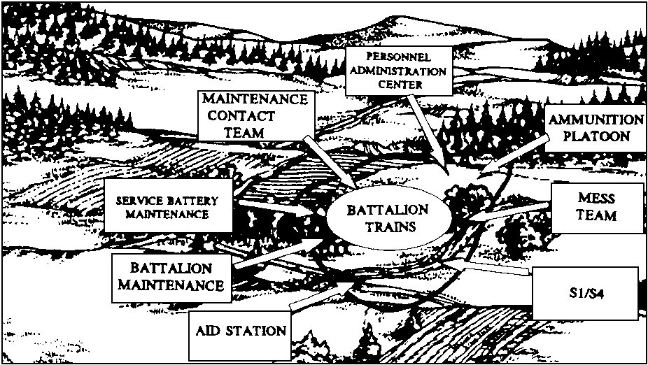

Figure 2-1. Unit Trains.

2. Dual (Combat and Field) Trains.

The preferred method of supporting the battalion is through echeloned trains. The battalion trains is normally made up of battalion CSS assets and elements of the FSB. Echeloning trains into combat (forward) and field (rear) trains provides:

- Immediately responsive forward support tailored to the tactical situation.

- Flexible resource usage.

- Increased resource survivability.

- Enhanced responsiveness when the tactical situation is very fluid or the supported unit is operating over extended distances.

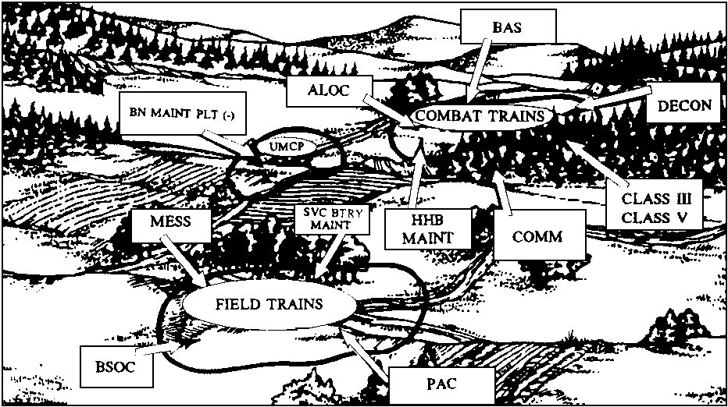

Figure 2-2. Dual Trains.

The battalion combat trains is organized to provide immediate critical CSS. It can include the following:

- POL (awaiting distribution to the batteries).

- Ammunition sections (awaiting distribution).

- Maintenance contact teams with recovery capability.

- A battalion aid station.

- The combat trains ALOC.

- Decontamination assets.

- Up-loaded Classes III and V vehicles.

- Elements of the communications platoon.

- The nearby unit maintenance collection point (UMCP).

- Some supporting elements from the FSB or FAST.

The combat trains is commanded by the HHB commander; the ALOC is supervised by the S4, assisted by the PSNCO. Elements of the combat trains are linked to the combat trains ALOC by landline.

Battalion combat trains should be close enough to the FLOT to facilitate responsive support to forward units. If possible, the combat trains should not be positioned within range of enemy indirect fire. It will generally occupy an area between the BSA and the forward battery or platoon position areas (5 to 8 km behind the batteries). Combat trains can expect to move often to stay in supporting distance of the firing units.

A unit maintenance collection point can be established to provide forward maintenance support to the battalion. It is supervised by the battalion maintenance technician, and is normally located in or near the battalion combat trains. The combat trains and UMCP, if normally located separately, may be combined to form a base cluster for defense.

The field trains is organized from elements not included in the combat trains and not required for immediate support of the batteries. The field trains is usually in the BSA and is commanded by the service battery commander. The elements include:

- The personnel and administration center (PAC).

- The remaining maintenance sections (to perform scheduled maintenance and maintenance for trains elements).

- The remaining battalion ammunition trains.

- Supply and food service sections.

The field trains CP is referred to as the battalion support operations center (BSOC). The BSOC is supervised by the S1, assisted by the battalion S4 NCOIC.

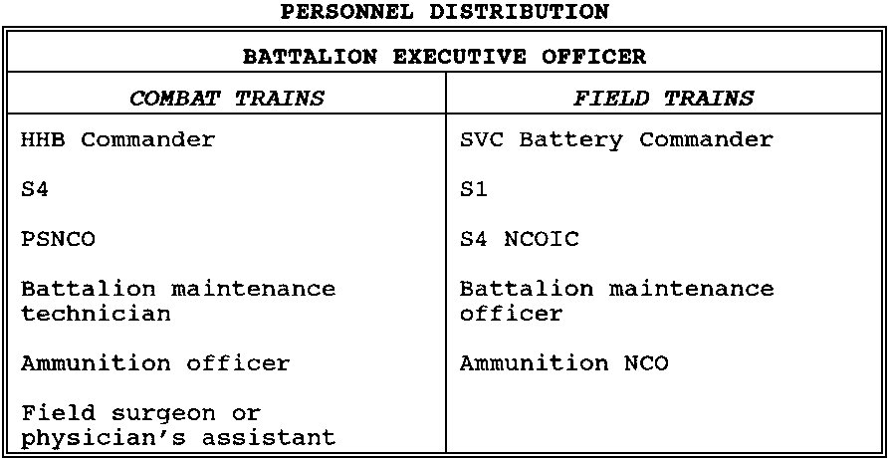

Figure 2-3. Personnel Distribution.

NOTE: The distribution personnel represented in figure 2-3 above may vary. A 1988 study conducted by the supply and maintenance management division (SMMD Gunnery Department USAFAS) revealed that field artillery commanders tailor their trains organization to fit specific needs, as the discussion in Part D of the lesson illustrates.

PART D: DETERMINING TRAINS ORGANIZATION

A commander must consider several factors when determining the organizational structure of the trains. Some of the more important considerations follow:

1. Status of Unit Personnel and Equipment.

The commander always considers the unit personnel and equipment in determining the trains organization. Unit commanders need to consider the personnel resources available, their capabilities, and the equipment available. This factor alone could dictate a single trains location.

2. Phase of Combat.

Just as the offense or defense affects the organization of field artillery for combat, it also affects the trains organization. In defense, the battalion can afford to be more centralized, since friendly forces "own" the ground. Routes have been reconnoitered, supplies and ammunition are stockpiled, and communications lines are laid and ready. In the offense, the situation is more fluid and the terrain is likely to be unfamiliar. Communication is mostly by radio, routes have not been reconnoitered, and there are no stockpiles for the firing batteries. Responsiveness is the key to maintaining the offensive. During offensive operations, the dual location may be preferred. In the defense, a single location may be preferred. Even then, the type of defense must be considered. A highly mobile, fast-moving situation such as exists in the covering force area might dictate a dual trains location.

3. Survivability.

The threat may influence the trains organization. If the threat of ground attack is great, using the unit trains concept may increase ground defense capability. If air attack or indirect fire is the primary threat, dual locations increase dispersion and afford smaller targets.

4. Location of the Brigade Support Area.

The distance from the BSA to the FLOT is also a factor. Short distances allow responsive support to the batteries from a single location. As the distance increases, responsiveness from a single location decreases. This is because much of the support provided by battalion depends on those elements located in the BSA. Although splitting into two locations does not decrease that distance, it decreases the turnaround time between battery and battalion locations.

5. Terrain.

The availability of terrain in the brigade sector may dictate the use of single rather than dual locations. Terrain also may affect the turnaround time for support. An area with paved, well-marked supply routes between elements is conducive to a single location, while restrictive terrain slows the support effort. Thus, terrain can be just as important a determinant as the distance itself.

6. Amount of Centralization.

The amount of centralization is also a deciding factor in determining trains organization. The more independent the batteries remain (maintaining their own mess, maintenance, and supply), the easier it is for the battalion to provide support from a single location. That is not to say that a battalion with a completely decentralized CSS effort cannot have dual locations; it certainly may. In fact, dual locations aid in the dispersal of units and may even increase the responsiveness to the batteries. A battalion that does not run a centralized CSS effort, however, may be forced into dual locations to stay responsive.

7. Responsiveness.

However the commander organizes his CSS effort, the idea behind the entire operation is to maintain maximum responsiveness.

PART E: TRAINS COMMAND AND CONTROL,
COMMUNICATIONS, AND TRAINS SECURITY.

1. Command and Control of Trains.

Command and control of CSS elements are the responsibility of the battalion XO. The S4 routinely coordinates all logistics operations, and the S1 coordinates all personnel and administrative operations. Both follow the XO's guidance. C2 facilities are the combat trains ALOC and the field trains BSOC.

The combat trains ALOC includes enough S1 and S4 personnel cross-trained to ensure continuous operations. They:

- Stay abreast of the tactical situation.

- Monitor the battalion command net to identify CSS requirements.

- Receive requests, reports, and requirements from subordinate elements.

Subordinate requirements are analyzed, consolidated, and forwarded to the field trains BSOC or to the appropriate supporting agency. The S1 or battalion S4 NCOIC coordinates and directs elements in the field trains to take action to meet the requirements of the forward units.

The field trains BSOC is the coordination and control center for the battalion S4 section, PAC, maintenance platoon, and battalion supply section. Personnel from these sections operate the field trains BSOC under supervision of the battalion S1. The battalion S1 coordinates all requirements for battalion organic and attached elements with all units in the BSA and with parent units as necessary.

2. Trains Communication.

At battalion level, CSS communication may include any combination of FM radio, mobile subscriber equipment (MSE), messenger, or wire. The admin/log radio net is used for most CSS traffic. For lengthy reports, messenger, wire, RATT, or facsimile is used.

The combat trains ALOC is the net control station (NCS) for the admin/log net. The S4, S1, HHB and service battery commanders, BMO, BAO, medical section OIC, and others (as required) operate in the battalion admin/log net. The combat trains ALOC also operates in the brigade admin/log net and in the battalion command net.

Procedures for submission of routine reports (such as the personnel daily summary and the DA Form 2406 [Material Condition Status Report]) should be established by SOP and included as a part of LOGPAC operations. These reports should be consolidated by battery and delivered in a standard packet for update in both the ALOC and the BSOC.

Communication is critical to expedite the CSS effort. Batteries must report their losses and requirements as soon as practical. New automated logistics systems, augmented with burst digital communications capabilities, will provide CSS personnel with a means to relay real-time CSS requirements. CSS systems, such as the unit level logistics system (ULLS), will permit constant monitoring of individual units current and projected needs.

When use of radio is not possible, messages are sent with resupply or evacuation vehicles. The combat trains ALOC and field trains BSOC maintain control of vehicles moving forward to logistics release points (LRPs) where units will rearm, refuel, and refit. Battalion SOP establishes procedures for resupply without request in case communications fail.

3. Trains Security.

The CSS elements behind the FLOT cooperate and coordinate their defensive plan to form base clusters. They must be prepared to defend themselves against guerrillas, partisans and forces that have broken through friendly defenses or that were bypassed in offensive operations.

The service battery commander is responsible for trains security when in a unit trains configuration. When trains are echeloned, the HHB commander is responsible for securing the combat trains and the service battery commander is responsible for securing the field trains. When the battalion commander collocates his field trains with the BSA, the service battery commander coordinates with the FSB commander or FASCO and the brigade rear CP to integrate the battalion field trains into the BSA defensive plan. In all trains areas, a perimeter defense is planned. Elements in the trains are assigned a specific sector to defend. Mutually supporting positions that dominate likely avenues of approach are selected for vehicles armed with heavy machine guns. Reaction forces and observation posts are established. To enhance security, an alarm or warning system is arranged. Sector sketches, fire plans, and obstacle plans should be prepared. Rehearsals are conducted to ensure that all personnel are familiar with the defensive scheme. The OIC at each location establishes a shift schedule for operations and security on a 24 hour basis.

PART F: TRAINS POSITIONING

The battalion S4 coordinates with the XO, S3, S2 and HHB and service battery commanders when selecting the trains location. Just as with cannon battery positions, the trains position must be coordinated with the maneuver commander who owns the ground.

1. Location.

On occasion, the field trains location may be selected by someone other than the S4 if the field trains is to be located with another element, such as a maneuver brigade trains. Such a location facilitates coordination between the battalion and the representatives from forward direct support logistics units. It also enhances security for battalion elements. However, turnaround time, communications requirements, or other mission-related considerations may require that the field trains be located elsewhere. When the field trains is located in the BSA, the exact location is selected by the brigade S4.

A good trains location will have the following:

- Defensible terrain--to allow the selective use of limited personnel assets.

- Sufficient space--to permit the dispersion of both vehicles and activities.

- Firm ground--to support the heavy ammunition and POL vehicles.

- Landing pad--for both aerial resupply and medical evacuation.

- Road network--to the batteries and back to higher-level CSS elements; also, a suitable network within the position.

- Communications--both forward to the batteries and to the rear to other CSS elements.

- Water--if possible.

- No undesirable terrain features--to avoid obstacles to CSS operations (such as a river) and targeting sources for the enemy.

Built-up areas are good locations for trains because they provide cover and concealment for vehicles and sheltered areas for maintenance operations at night. When built-up areas are used, trains elements should occupy buildings near the edge of the area to reduce their chances of being trapped.

Seldom will a site be found that has all of the desirable traits. Those most important to the mission and tactical situation should be given priority.

2. Supply Routes.

The battalion S4 is also responsible for selection of battalion supply routes for resupply, evacuation, and maintenance support. The proposed routes should extend forward from the support elements in the brigade or division area to the batteries. Primary and alternate routes should be planned and coordinated with the FA S3 and the maneuver commander to avoid interference with maneuver elements. Coordination with adjacent combat, combat support, and combat service support units is necessary to ensure adequate movement of support resources forward and to the rear.

3. Trains Displacement.

Proper positioning of trains can minimize displacements and increase the quantity and quality of support. The trains can be displaced as a whole along with the battalion or by echelon to permit continuous CSS, or it may infiltrate in modular form to its next position.

THIS PAGE IS INTENTIONALLY LEFT BLANK

LESSON 2

PRACTICE EXERCISE

The following items will test your knowledge of the material covered in this lesson. There is only one correct answer for each item. When you complete the exercise, check your answer with the answer key that follows. If you answer any item incorrectly, study again that part of the lesson which contains the portion involved.

1. CSS responsibility at battery or platoon level consists of

A. manufacturing needed materials.
B. transporting bulk supplies to forward sections.
C. planning logistics support operations.
D. reporting requirements and requesting support.

2. The ______________ and his staff primarily perform strength accountability, replacement operations and administrative services.

A. S-4
B. S-3
C. S-2
D. S-1

3. The _________________ is responsible for the logistical support of the battalion.

A. S-1
B. S-2
C. S-3
D. S-4

4. T F The S1 is responsible for enemy prisoners of war (EPW) operations.

5. T F The S4 is responsible for obtaining water and maps.

6. T F Personnel in the S1 and S3 section are cross-trained in critical tasks so that they are able to provide continuous operations.

7. The _____________ is a grouping of equipment and vehicles to provide logistical support to battalion elements (batteries).

A. Battalion Log convoy
B. Service support trains
C. Battalion Trains
D. Unit trains

8. T F Combat trains provide critical battlefield support to the firing batteries.

9. T F Centralized logistical resources are called Field Trains.

10. T F Slow-moving situations may justify the use of Unit Trains.

11. T F Light FA battalions never operate under a Unit Trains organization.

12. In heavy organizations, the preferred method of supporting the battalion is through _____________ trains.

A. organizational
B. unit
C. single
D. echeloned

13. T F Combat trains, organized to provide immediate critical CSS, may include POL, Decontamination assets, and Ammunition sections.

14. T F The Combat Trains is commanded by the Firing Battery Commander.

15. T F The field trains is commanded by the Service Battery Commander.

16. T F The field trains CP is referred to as the Battalion Support Operations Center (BSOC).

17. T F Use of single (unit) trains is preferred in conducting offensive operations.

18. A primary threat of air attack may indicate use of_____________ trains, and a primary threat of ground attack may indicate the use of______________ trains.

A. dual; unit
B. unit; dual
C. dual; split
D. unit; single

19. T F The combat trains ALOC is the radio net control station for the Bn's admin/log net.

20. T F When using the unit trains configuration, the S2 is responsible for trains security.

LESSON 2

PRACTICE EXERCISE

ANSWER KEY AND FEEDBACK

Item Correct Answer and Feedback

1. D. reporting requirements and requesting support.

The CSS responsibility at battery or platoon level . . . (Page 2-1, Part A)

2. D. S-1

The S1 and his staff perform the critical tasks of strength accountability, . . . (Page 2-2, Part A, para 2.)

3. D. S-4

The S4 is responsible for the logistical support of the battalion . . . (Page 2-3, Part A, para 5.)

4. T

The S1 also has primary staff responsibility for enemy prisoners of war (EPW) operations . . . (Page 2-2, Part A, para 2.)

5. T

The S4 section is responsible for obtaining water and maps. (Page 2-3, Part A, para 5.)

6. F

Personnel in the S4 and S1 sections are cross-trained in critical tasks . . . (Page 2-3, Part A, para 5.)

7. C. Battalion Trains

The battalion trains is a grouping of equipment and vehicles to provide logistical support to the batteries. (Page 2-6, Part C.)

8. T

Elements providing critical battlefield support forward with the batteries are called "combat trains." (Page 2-6, Part C.)

9. F

If logistical resources are centralized in one location, they are called unit trains. (Page 2-6, Part C, para 1.)

10. T

Unit trains may be appropriate in slow-moving or static situations . . . (Page 2-7, Part C, para 1.)

11. F

Light FA battalions usually operate under a unit trains organization. (Page 2-7, Part C, para 1.)

12. D. echeloned

The preferred method of supporting the battalion is through echeloned trains. (Page 2-8, Part C, para 2.)

13. T

The battalion combat trains is organized to provide immediate critical CSS. It can include . . . (Page 2-8, Part C, para 2.)

14. F

The combat trains is commanded by the HHB commander. . (Page 2-9, Part C, para 2.)

15. T

The LOGPACs are organized in the field trains under the supervision of the service battery commander . . . (Page 2-9, Part C, para 2.)

16. T

The field trains CP is referred to as the battalion support operations center (BSOC). . . (Page 2-9, Part C, para 2.)

17. F

In the offense, the dual location would be preferred. (Page 2-11, Part D, para 2.)

18. A. Dual; unit

If the threat of ground attack is great, unit trains may increase . . . If air attack or indirect fire is the primary threat, . . . (Page 2-11, Part D, para 3.)

19. T

The combat trains ALOC is the net control station (NCS) for the admin/log net. (Page 2-13, Part E, para 2.)

20. F

The service battery commander is responsible for trains security when in a unit trains configuration. (Page 2-13 & 14, Part E, para 3.)

THIS PAGE IS INTENTIONALLY LEFT BLANK

LESSON 3

PLANNING AND EXECUTION OF FIELD ARTILLERY BN CSS OPERATIONS

OVERVIEW

LESSON DESCRIPTION:

This lesson discusses how CSS operations are planned and conducted in a field artillery battalion. This portion of the subcourse will describe how artillery units receive different classes of supply and how support services are provided.

LEARNING OBJECTIVE:

ACTIONS: Identify how artillery units plan for and conduct CSS operations, and how field artillery units receive different classes of supply and support services.

CONDITION: Given the material contained in this lesson.

STANDARD: Correctly answer all questions in the practice exercise at the end of this lesson.

REFERENCES: The material contained in this lesson was derived from the following publications: FM 6-20-1; TC 6-50; and selected articles from Military Review and the Field Artillery Journal.

INTRODUCTION

CSS planning is conducted to ensure support during all phases of an operation. The CSS plan is developed concurrently with the tactical plan. Supporting CSS plans are as detailed as time permits. Use of SOPs and planning for contingencies greatly help the CSS staff officer in the planning effort. The FA support plan addresses only deviations from the routine procedures established in unit SOPs.

PART A: PLANNING CSS OPERATIONS

1. Planning for changing missions.

Flexibility, innovation, and anticipation must characterize CSS planning and execution. Not
every brigade is always committed to the close battle. Operations of the covering force, rear
area operations, and contingency missions also require resources. Close support battalions
are not always assigned a DS mission. They are likely to have Reinforcing (R), General
Support Reinforcing (GSR), or General Support (GS) missions at some point in the battle. Logistical
support for the transition from GSR or GS to DS and vice versa requires detailed planning and thorough

coordination. Similar transition planning must occur when nondivisional cannon battalions operate in one brigade or division area during one phase of the operation and in another area during subsequent phases.

Transition from one area of operation to another normally results in a change in support battalions (heavy forces) or companies (light forces). Therefore, units must forecast future needs with the gaining FSB. They must relentlessly coordinate to complete the transfer of logistical responsibilities and to ensure all classes of supply are forwarded through the gaining FSB or company to the unit. Of particular interest are the unique planning requirements for Classes V and IX supplies and maintenance support.

Each ammunition transfer point (ATP) is normally designed to support a three- or four-battalion maneuver brigade including a DS artillery battalion. However, the addition of one or more GS or GSR artillery unit(s) (often of different caliber than the DS unit) may quickly exceed the capacity of the forward support battalion ATP. Realistic positioning of ATPs to support the main effort, as well as identifying additional transportation assets needed to support the ATPs, is essential.

It may be necessary to identify authorized stockage list (ASL), then push packages and maintenance support teams from the losing FSB to augment the gaining FSB in support of additional FA units. It is critical to identify ASL and maintenance support team requirements for nondivisional units. These assets must be thoroughly coordinated with corps support units and provided to the supporting divisional forward or main support battalion or company.

2. Planning principles.

The CSS functions are anticipative in nature; they are performed as far forward as the tactical situation permits. Support must be continuous, and immediately available assets must be used. Ammunition, fuel, repair parts, end items, maintenance personnel, and replacements are pushed as far forward as possible.

CSS planning is a continuous function. Coordination among CSS and tactical planners is essential. It should address all factors that can have a significant effect on the tactical mission. Use of authorized knowledge based logistics, planning systems will facilitate logistics planning.

The CSS staff officers and commanders must act rather than react to support requirements. Personal involvement, remaining abreast of the tactical situation, and on-the-scene appraisal of the situation by CSS personnel are critical to mission accomplishment. "Only if the team gets to the stadium in time,

with the proper equipment, can the game be played at all."--Military Review April 1991.

To ensure effective support, CSS operators and planners must understand the commander's tactical plans and intent. They must know:

- What each of the supported elements will be doing.

- When they will do it.

- How they will do it.

- The current and proposed locations of the supported units.

- What the tactical situation is.

After analyzing the concept of operations, CSS planners must be able to accurately predict support requirements. They determine:

- What type of support is required.

- What quantities of support are required.

- The priority of support by time, type, and unit.

Support capabilities are assessed as follows:

- What CSS resources are available (organic, lateral and higher headquarters).

- Where the CSS resources are.

- When CSS resources can be available.

- How support capabilities can be made available.

On the basis of this analysis, CSS plans are developed that apply resources against requirements.

3. Support of the Offense.

If offensive momentum is not maintained, the enemy may recover from the shock of the first assault, gain the initiative, and mount a successful counterattack. Therefore, the CSS priority must be to maintain the momentum of the attack.

A successful attack may develop into an exploitation or a pursuit. The CSS planners must be flexible enough to support either type of operation. The following techniques in Figure 3-1 are used by CSS planners for offensive planning:

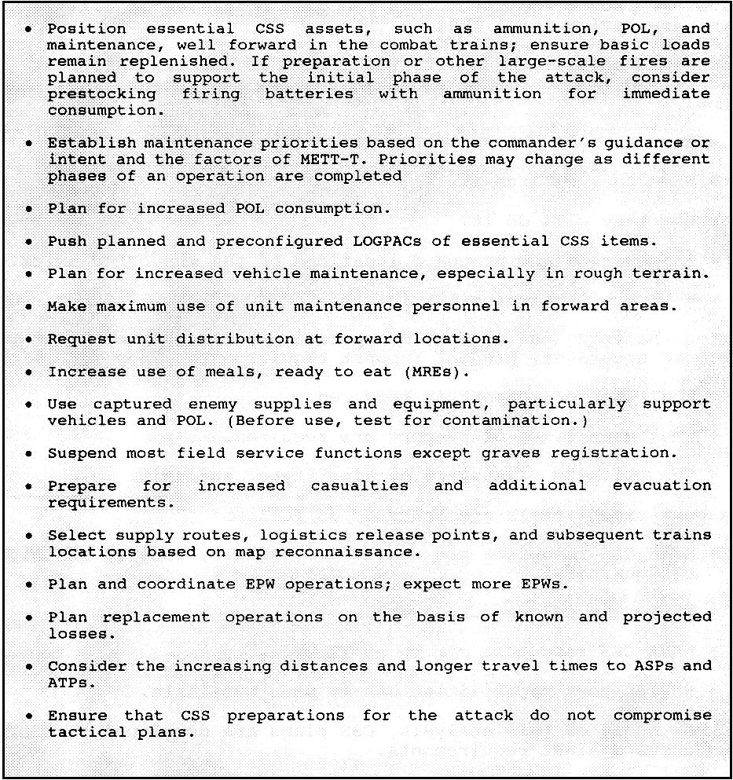

Figure 3-1.

The considerations in Figure 3-1 apply to all offensive operations. The change from one type of operation to another, such as from a hasty attack to a pursuit, does not require a major shift in CSS plans and procedures; however, the priorities and requirements for support may change. The XO, assisted primarily by the S4, organizes the battalion CSS assets to permit

uninterrupted support. The main purpose of CSS in the offense is to allow the force to maintain the momentum of the attack.

4. Support of the Defense.

The immediate purpose of the defense is to cause an enemy attack to fail. As in offensive operations, perhaps the most critical time is the preparation stage. General considerations in preparing for defensive operations include the following:

- Pre-position limited amounts of ammunition and POL in a centrally located position in the forward area. Make plans to destroy those stocks if necessary.

- Resupply during limited visibility to reduce the chance of enemy interference.

- Plan to reorganize or reconstitute lost CSS capability. Identify personnel from the field trains as potential replacements to reestablish the lost capability.

- Consider the additional requirements for obtaining and moving Class IV reinforcement material and pre-positioned ammunition.

5. Continuous Support.

The CSS elements conduct sustainment operations continuously. When batteries are not firing, battalion CSS elements may take advantage of the lull to prepare the elements for the next operation. Maintenance, repair work, and normal services are performed whenever possible.

Emergency resupply is conducted when needed; routine resupply is usually conducted daily. Vulnerability and limited cross-country mobility of CSS vehicles dictate that LOGPACs use existing roads.

Continuous CSS operations require careful personnel management. A carefully planned and strictly enforced rest-work schedule or sleep plan is necessary to ensure continuous capability. Also, CSS personnel must not be overly burdened with administrative housekeeping tasks (guard, details, and so forth) to the point that they are unable to do their primary mission.

6. Logistics Estimate.

The decision-making process involved in a logistics estimate is as simple or as complex as the
time available and the tactical situation allow. When the commander receives the mission, the
estimate process begins. The XO's staff, and other logisticians in the battalion gather and
analyze information, prepare an estimate, and brief the commander. Emphasis is on how the status

of CSS will impact on a proposed course of action. A logistics estimate is a continuous analysis of logistics affecting mission accomplishment, used to recommend courses of action and to develop plans to support the selected course of action. Key concerns of battalion logistics planners are the status of supply Classes III, IV, and V and the operational status of equipment. For more information, see FM 101-5.

Logistics estimates at the battalion level are rarely written. They are often formulated in terms that answer the following questions:

- What are the current and projected status of personnel maintenance, supply, and transportation?

- How much of what is needed to support the operation?

- How will it get to where it is needed?

- What external (FSB or FAST) support is needed?

- Can the requirements be met by using LOGPAC operations, or are other techniques necessary?

- What are the shortfalls and negative impacts?

- What courses of action can be supported?

Again, use of automated logistics planning systems will facilitate the decision-making process.

PART B: LOGISTICAL SUPPORT

The battalion always maintains some combat-essential supplies and repair parts. These are called basic loads and prescribed load lists. The minimum stockage level is normally directed by division or higher. These loads allow a unit to sustain itself in combat for a limited period should there be an interruption in the resupply system.

The battalion has three methods by which to replenish its stocks. They are: supply point distribution; unit distribution; and rearm, refuel, resupply point (R3P) distribution.

1. Supply Point Distribution.

The battalion, using organic transportation, goes to the supply point to pick up supplies. This is the normal method used by the battalion S4 section to pick up supplies.

2. Unit Distribution.

Supplies are delivered to the battalion by transportation assets other than its own. When feasible, supplies are shipped directly from the issuing agency as far forward as possible, if the receiving unit has the material handling equipment necessary. This means that some supplies may be issued directly to the battalion from COSCOM or even theater Army level, especially Classes III and VII. This issue usually occurs no farther forward than the field trains. The battalion will then use its transportation assets to resupply its subordinate elements.

Logistics packages (LOGPACs) facilitate the efficient resupply of forward units. The LOGPACs are organized in the field trains under the supervision of the service battery commander and the battalion S4 NCOIC. They are moved forward to the LRPs at least daily for routine resupply. Special LOGPACs are organized and dispatched as required by the tactical situation and logistical demands.

An S4 representative, the OIC or NCOIC organizes a convoy for movement of all battery LOGPACS under his control. The convoy may contain additional vehicles, such as a maintenance vehicle with Class IX supplies to move to the UMCP or an additional ammunition or fuel vehicle for the combat trains. The LOGPACS move along the MSR to a logistics release point (LRP), where the unit supply sergeant or unit guide takes control of the battery LOGPAC.

From the LRP, the battery supply sergeant or guide controls the LOGPAC and conducts resupply. The supply sergeant informs the S4 representative of requirements for the next LOGPAC. Outgoing mail, personnel, and equipment are collected by the S4 representative for movement to the rear. The LOGPAC then follows unit SOP and returns to the LRP. Once all battery LOGPACs are back at the LRP, they convoy back to the field trains to reorganize for the next LOGPAC operation.

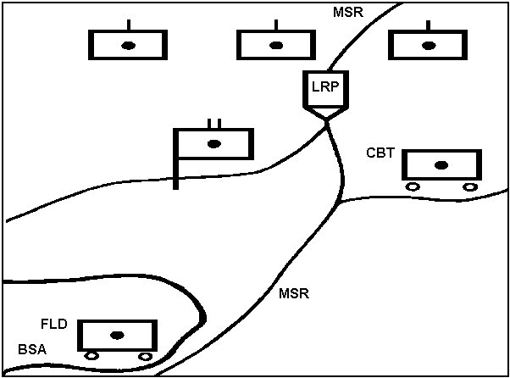

Figure 3-2. LRP.

3. Rearm, Refuel, Resupply Point Distribution (R3P).

This technique combines features of supply point and unit distribution, usually emphasizing Class III and V resupply requirements. R3P is typically conducted along the route of an extended battalion road march. Close coordination between the S3 and S4 is essential to ensure the proper selection of the location and timing of this supply action. The battalion S4 is responsible for the preparation of the R3P site; the battalion XO oversees the movement of units through this position.

While R3P distribution is rapid and often convenient, it does require that the unit take itself out of action to accomplish the resupply function. However, since the unit will normally perform R3P distribution in conjunction with a scheduled move, the overall loss of support capability should be minimal.

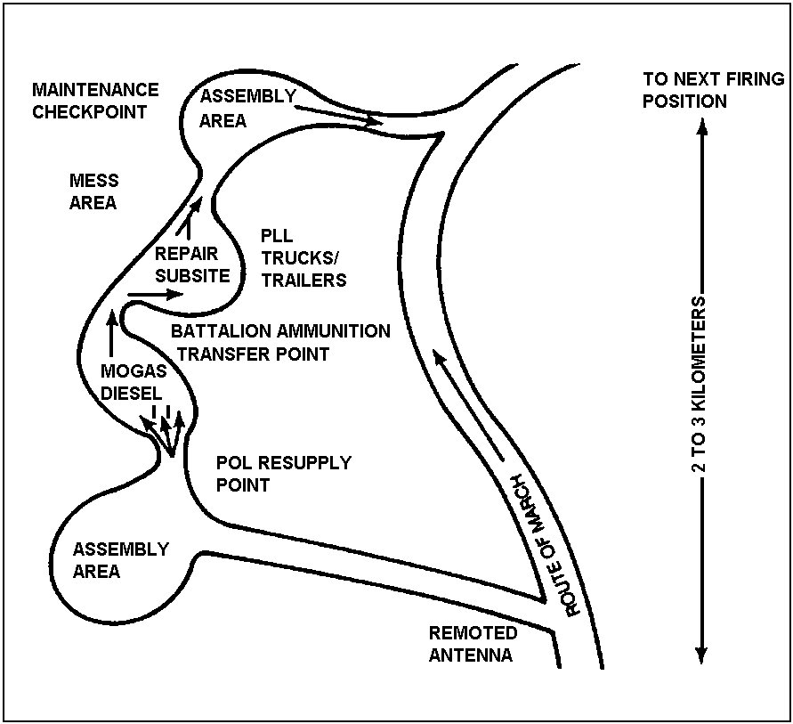

Figure 3-3. R3P.

4. Other resupply methods.

While the LOGPACs are the preferred method of resupply, there will be times when other methods of resupply are required. These methods include the following:

Resupply from the combat trains (emergency resupply). The combat trains have a limited amount of Classes III and V supplies for emergency resupply. The S4 coordinates emergency resupply from the combat trains and then refills or replaces the combat trains assets.

Prestocking. This is the placing and concealing of supplies on the battlefield. It is normally accomplished during defensive operations when supplies are placed in subsequent positions (for example, ammunition for immediate consumption).

Mobile pre-position. This is similar to prestocking, except that the supplies remain on the truck, which is positioned forward on the battlefield.

PART C: CLASSES OF SUPPLIES

The division of supplies into classes improves logistics planning and operations, thereby speeding requisitioning and distribution procedures.

The FA battalion normally coordinates directly with the FSB, FAST, or DISCOM supply activity. However, the Divarty or FA brigade (as appropriate) monitors items of command interest by means of SOP-directed reporting requirements. The following paragraphs briefly describe each class of supply as it impacts on the FA battalion.

1. Class I: Rations.

Brigade automatically requests Class I on the basis of daily strength reports for its supporting FA units. The combat trains ALOC forwards the strength report to the field trains BSOC. The mess section gets subsistence from the FAST or FSB supply company Class I point in the BSA. A- or B-rations are prepared in the field trains and delivered to the batteries and attached elements as part of the LOGPAC. T-rations may be prepared in the field trains and sent forward, or they may be pushed forward to the batteries and then prepared (heated) on site. The MREs stored on combat vehicles are eaten only when daily Class I resupply cannot be accomplished.

Water is not a Class I supply item, but is normally delivered with Class I. The service
battery commander or battalion S4 NCOIC coordinates with the FAST or FSB to
pick up water from the main support battalion (MSB) water supply point. Water can be

delivered to the units by use of water trailers or blivets. Also, forward water points can be tested and approved by the battalion surgeon. Each vehicle in the battalion should carry water cans to be refilled or exchanged during Class I resupply and LOGPAC operations.

2. Class II: Supplies and Equipment.

Class II supplies include clothing, individual equipment, tentage, organizational tool sets and kits, hand tools, and administrative and housekeeping supplies and equipment (including mission-oriented protective posture [MOPP] suits and decontamination items). The S4 section coordinates for pickup of Class II items from the FAST or FSB supply company in the BSA before normal LOGPAC operations.

3. Class III: Petroleum, Oil and Lubricants.

The brigade S4's POL forecasts form the basis for division and corps stockage levels. POL is normally obtained by the battalion S4 section from the supply company Class III supply point in the BSA. POL tankers carrying packaged POL products move forward with each LOGPAC. Refueling operations may be carried out in one of three ways:

- The fuel truck is taken to howitzer and vehicle positions.

- Howitzers and vehicles are moved to a centrally located fuel truck.

- All vehicles refuel during movement from one battery position to another (R3P).

Combat refueling (the use of 5-gallon cans) is an alternative to the above three methods. It is slower, but may be required when bulk refueling is not available or feasible. Battalion SOPs should prescribe procedures for all types of refueling.

4. Class IV: Construction Materials.

Class IV includes consumable items such as construction and fortification material and the lightweight camouflage support system. Requisitions for regulated Class IV items (fortification and barrier material) are submitted through command channels. Non-regulated items (small quantities of nails and common electrical, plumbing, and similar hardware items) are requested or obtained from the FAST, FSB, or DISCOM.

5. Class V: Ammunition.

The S4 plans for Class V operations and the ammunition officer supervises resupply operations. The S3, S4, and ammunition

officer must continually coordinate and exchange information concerning ammunition. Each must know the required supply rate (RSR), the controlled supply rate (CSR), and the authorized basic load (see Figure 3-4.). This information must also be provided to the battalion and battery commanders so they can plan resupply operations and set priorities. When additional artillery units are positioned to add weight to a particular area of the operation, the S4 should request periodic updates on ammunition availability.

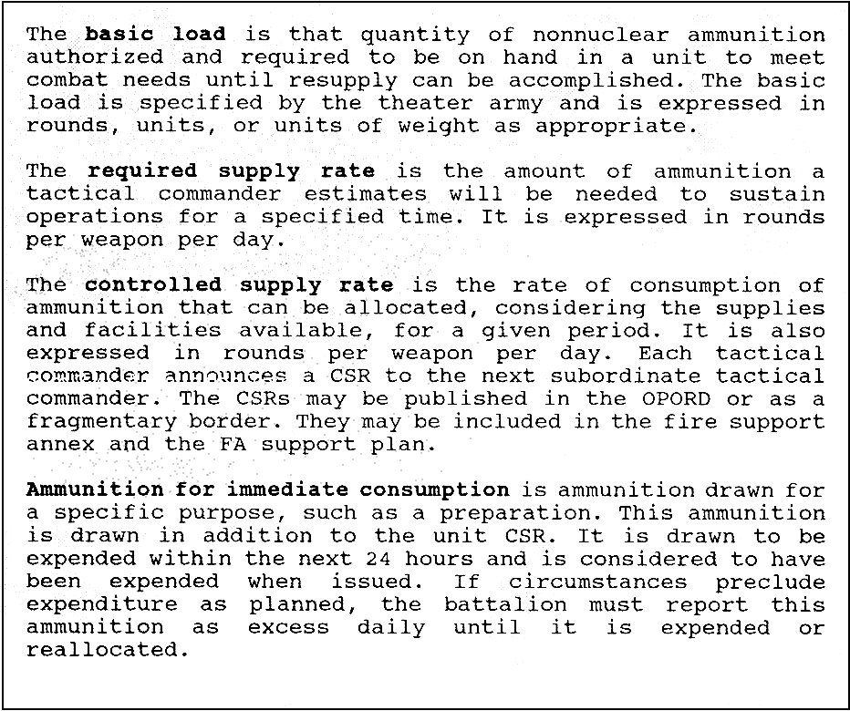

Figure 3-4. Ammunition Terms.

The tactical situation may warrant requesting extra ammunition for scheduled fires. With higher headquarters approval, the ammunition on hand in a unit may temporarily exceed that authorized (CSR). This approval is explicitly for ammunition for immediate consumption.

Such ammunition is drawn on the premise that it will be expended within 24 hours. If circumstances beyond unit control preclude expenditure within that time frame, excess ammunition must be reported to higher headquarters during each 24-hour period until the excess is expended or redistributed to other units.

For a more detailed discussion on Field Artillery ammunition resupply operations, see Part D of this lesson.

6. Class VI: Personal Demand Items.

Class VI includes personal items sold through COSCOM post exchanges (PXS). Requests for support are submitted by the S1 through administrative channels when no PX is available. In some cases, ration supplementary sundry packs are issued along with normal ration distribution.

7. Class VII: Major End Items.

The issuing of major end items (howitzers and ammunition carriers) is closely controlled through command channels. Issue priorities for the replacement of battle or other losses are based on item availability, unit mission, and the tactical situation. The DMMC processes requests (usually in the form of battle loss reports) from divisional units. These items may be delivered to the battalion, or the battalion may be required to pick up the items from a designated support unit. In some cases, weapon system replacement items (howitzers) may be provided to the battalion with crew, fuel and ammunition, preferably during routine LOGPAC operations. Weapon system replacement operations (WSRO) are discussed in detail in Part I of this lesson.

8. Class VIII: Medical Supplies.

Medical supplies are obtained through medical channels. For divisional battalions, the battalion medical section gets supplies from the divisional clearing station in the BSA. The battalion medical section provides organizational maintenance for medical items in the battalion. Maintenance above this level is obtained by evacuation through medical channels to the medical company in the BSA or to a comparable COSCOM element. For organizational maintenance, the medical section also stocks medical repair parts.

9. Class IX: Repair Parts.

The FA battalion stocks repair parts based on a prescribed load list. High-demand and combat-essential repair parts for vehicles, weapons (artillery and small arms), NBC equipment, and mess equipment are ordered and stocked by the battalion equipment maintenance clerk. Repair parts for C-E equipment
are stocked by the battalion communications platoon. Other repair parts are

stocked by battalion maintenance.

Repair parts are issued in response to a specific request or by repairable (direct) exchange. The battalion gets repair parts from the Class IX supply point in the BSA. Parts are moved forward during routine LOGPAC operations or as required to the UMCP. The maintenance section requests Class IX items (less repairable exchange) and major Class IX subassemblies, such as engines and transmissions. It submits requests to the maintenance platoon of the FAST or the maintenance company of the FSB. Repairable exchange for selected items (including components and subassemblies) is handled as a simple exchange with the DS maintenance unit of the unserviceable item (with an attached request for issue or turn-in) for a serviceable item. In combat, exchange and cannibalization are the norm to obtain critical Class IX supplies. Unit SOPs should identify who authorizes cannibalization operations during combat.

10. Class X: Material to Support Nonmilitary Programs.

Material to support nonmilitary programs such as agriculture and economic development, is not included in Classes I through IX. Class X items are requested and obtained by the S4 on the basis of civil-military requirements. Specific instructions for request and issue of Class X supplies are provided by division or higher.

PART D: AMMUNITION

The FA ammunition system involves the supply and expenditure of all ammunition that FA battalions are equipped to fire. Small-arms ammunition constitutes an insignificant portion of FA battalion daily tonnage requirements, and can be handled routinely with normal ammunition resupply. For nuclear and chemical ammunition resupply, see FM 100-10.

Normally, the BAO of each FA battalion is responsible for the resupply of ammunition to the firing batteries. He must know what ammunition is available at the ATP and/or ASP, what his CSR is, the current and anticipated expenditure rates, and locations (present and future) of the firing batteries and resupply points. This information can be obtained from OPORDs, fire support plans, and close and frequent coordination with his battalion S3 and/or operations section. The battalion XO or service battery commander must coordinate with the brigade S4 and the division ammunition officer (DAO) representative at the ATP to ensure that ATP organization and operations meet battalion requirements.

The BAO plans the use of the battery's ammunition-hauling assets and how to use and control convoys for ammunition pickup and delivery. He must plan the loads for each vehicle to allow for the delivery of complete rounds and to make maximum use of its carrying capacity. In coordination with the S3, the BAO must plan for the delivery of the appropriate types and lots of ammunition. Other aspects that must be considered include the following:

- The size of the convoy depends on the tactical situation and the level of training of ammunition personnel. If the unit is in heavy contact or the enemy has a good moving-target-acquisition capability, infiltration by a small group of vehicles might be best. Darkness or surge requirements may dictate the use of larger convoys

- Each convoy, regardless of size, must have one person in charge and a designated succession of control.

- All personnel must be able to read maps.

- Each firing battery should report the arrival of the ammunition convoy to the battalion operations section.

- Ammunition carrier loads must be configured to have complete rounds of ammunition.

- If possible, a series of standardized preconfigured ammunition loads should be developed and the ammunition sections trained to use them. This allows flexibility and saves time when briefing crews and uploading carriers.

On demand, ammunition is sent to a firing battery. The XO, platoon leader, FDO, chief of firing battery, and platoon sergeant signs a hand-receipt for ammunition received.

NOTE: Hand-receipting for ammunition may become an obsolete procedure when the army adopts an automated bar-coding inventory system for ammunition.

For more information on ammunition preconfigured loads and the maneuver-oriented ammunition distribution system (MOADS), see Appendix A, The Evolution of Ammunition.

PART E: MAINTENANCE

Maintenance involves inspecting, testing, servicing, repairing, requisitioning, and recovering equipment.

1. Maintenance Forward.

Combat power is maximized when disabled equipment is repaired as far forward and as quickly as possible. The BMO, in coordination with the XO, directs the maintenance effort for the battalion. He uses established time guidelines (See Figure 3-4) and coordinates maintenance actions.

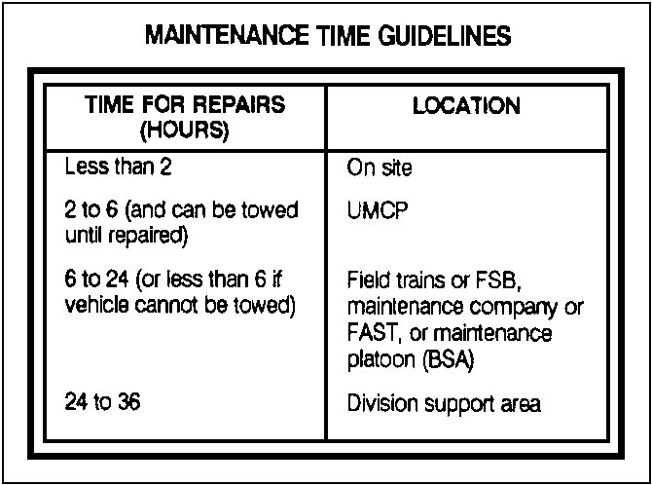

Figure 3-5. Maintenance Time Guidelines.

Battle damage assessment and diagnosis indicate repair time. An item is repaired on site or recovered directly to the appropriate maintenance echelon in the appropriate support area. The location is based on the following:

- Tactical situation.

- Echelon of work required.

- Availability of required repair parts.

- Current workload in each area.

- Maintenance time guidelines.

2. Maintenance Concepts.

The following discussion of battlefield maintenance concepts places the various maintenance echelons into proper perspective. The discussion illustrates how echelons overlap to provide continuous maintenance support to the batteries.

The BMO task-organizes the maintenance platoon according to his analysis of current and anticipated requirements. He is concerned with providing the appropriate support at each of three locations: the battalion, the Unit Maintenance Collection Point (UMCP), and the field trains.

Normally, the battalion provides each battery its habitual associated maintenance team. Usually, the battalion's three recovery vehicles (VTRs) (heavy divisions only) are positioned forward with each firing battery but remain under battalion control. This provides a quick-fix capability for those items that can be repaired in less than 2 hours and a recovery capability for those items not requiring extensive repairs. Items that will require more than 2 but less than 6 hours to repair are evacuated to the battalion's UMCP. Vehicles requiring extensive repair times are evacuated to the field trains or DS maintenance facilities in the BSA.

The UMCP is normally established next to the combat trains. It includes the maintenance platoon headquarters, HHB maintenance team and PLL, number 2 common tool kit and welding equipment, and the DS maintenance support team (MST). The task organization of the UMCP is modified according the BMO's analysis of maintenance requirements and the tactical situation. It is supported by the battalion maintenance technician (BMT) and the senior maintenance supervisor.

Anything that cannot be repaired in less than 6 hours or cannot be towed by UMCP assets is recovered to the field trains or directly to the FSB maintenance company or FAST maintenance platoon in the BSA.

NOTE: DS FA battalions organic to light divisions do not have the personnel or equipment assets to implement as described. However, the concept is valid for light units and must be adjusted on the basics of the unit's organic capabilities.

Recovery may be done by battery or battalion maintenance team VTRs, 5-ton wreckers, or
a combination of both and heavy equipment transporters (HETs), which can be
requested through the FSB maintenance company. The BMT coordinates and directs the

method to be used. The use of HETs is preferred, but they are restricted by road requirements and availability. Some crew members will stay with the vehicle to help mechanics repair the vehicle and to return it to the unit. They also man operational weapon systems on the vehicle to provide additional security for rear areas.

In the field trains, remaining elements of the battalion maintenance platoon perform other tracked and wheeled vehicle maintenance and Class IX resupply. The battalion motor sergeant coordinates requirements with the service battery commander or S4 and with the maintenance element of the FSB or FAST. He also coordinates maintenance requirements with the parent headquarters of any attached or supporting elements working with the battalion.

PART F: FIELD SERVICES

1. Graves Registration.

Graves registration services are provided by the MSB supply and service company. Graves registration at battalion level consists of three functions: collection, identification, and evacuation. DA Forms 1156 (Casualty Feeder Reports) and DA Form 1155 (Witness Statement on Individual) are completed by the soldier who has knowledge of the casualty. The forms are sent to the field trains with the returning LOGPAC. Military equipment is collected and turned over to the supply sergeant to be forwarded during LOGPAC operations. Remains are placed in a human remains pouch, along with personal effects, and evacuated with returning LOGPAC vehicles to the field trains. A collection point may be established, if necessary, at the combat trains under the control of the S4. In any case, remains are evacuated as quickly as possible to the brigade collection point in the BSA. (See FM 10-63-1.)

2. Clothing Exchange and Bath.

Clothing exchange and bath (CEB) services are provided by the MSB supply and service company or the supply and transport battalion in the DISCOM of the LID. Clothing exchange (or gratuitous issue) and bath service are requested from the MSB through the brigade S4. A request for CEB service must specify the following:

- The location of the unit making the request.

- The desired time for service.

- The range of clothing sizes for unit members.

The requesting unit must be prepared to help set up the CEB operation. Normally, there is one CEB point per BSA.

3. Salvage.

A salvage collection point is established in the BSA by the FSB supply company or FAST supply section. It receives serviceable, unserviceable (repairable), discarded, abandoned, and captured supplies and equipment. The salvage point will not accept COMSEC or medical supplies, toxic agents, radioactive materials, contaminated equipment, aircraft, ammunition and explosives.

4. Laundry and Renovation.

Laundry and renovation services are provided by corps (COSCOM) when the tactical situation permits. This service is coordinated through the brigade S4.

5. Transportation.

Transportation is the means of distributing supplies, evacuating damaged equipment, and moving personnel to where they are needed. Should the battalion require transportation support beyond its organic capabilities, the S4 forwards a request to the brigade, Divarty, or FA brigade S4, who then forwards it to the movement control officer (MCO) at DISCOM or COSCOM. The MCO makes a determination based on requirements and existing priorities.

PART G: PERSONNEL SERVICES SUPPORT

Personnel and health services support functions sustain the morale and welfare of the soldier. At battalion level, these include personnel and administrative (P&A) services, chaplain activities, legal services, finance services, postal services, EPW support, and health services support.

1. Personnel and administrative services.

The P&A services are the responsibility of the battalion S1. They are discussed below.

Strength Accounting. Batteries and attached elements submit a personnel daily summary report to the S1 representative in the combat trains ALOC. The S1 forwards a battalion consolidated report through brigade S1 to the division G1 and/or adjutant general (AG) at the division main CP. These reports are the basis for individual replacements and Class I resupply.

Casualty Reporting. The S1 ensures that both strength and casualty reporting are timely and accurate. Reports are initiated by the section chief or any individual having knowledge of the incident. DA Form 1156
is carried by all small-unit leaders, and is used to report battle and nonbattle casualties. When a soldier

is reported missing or missing in action or when the remains are not under US control, DA Form 1155 goes with the DA Form 1156. The first sergeant collects the reports and forwards them to combat trains ALOC. The S1 cross-checks the reports, requests any needed clarification, adjusts unit strength reports, and forwards the reports through the PAC to the brigade S4.

Replacement Operations. Replacement flow is monitored by the PAC in the field trains. The service battery commander establishes a replacement receiving point (RRP) in the field trains and notifies the brigade S1 of its location. All replacements or hospital returnees are brought to the RRP for initial processing.

Other Administrative Services. During lulls in the battle, the S1 and PAC complete all other P&A actions necessary. Special consideration is given to timely processing of awards and decorations.

2. Chaplain Activities.

Chaplain activities are provided by the unit ministry team (one chaplain and one chaplain's assistant) operating from the combat trains. This team is dedicated to serving the spiritual needs of soldiers. Chaplain activities include the following:

- Providing worship opportunities.

- Administering sacraments, rites, and ordinances.

- Providing pastoral care and counseling.

- Advising the commander and staff on matters of religion, morals, and morale.

- Ministering to those suffering battle fatigue.

- Providing religious support to enhance soldier morale and unit cohesion.

- Routinely visiting unit soldiers in nearby hospitals. The activities of the chaplain are coordinated through the S1 and are published in paragraph 4 of the FA support plan.

3. Legal Services.

Legal services support is coordinated by the S1 section. It is provided to the battalion on a general support basis by the staff judge advocate of the division. It includes the following:

- Legal advice to commanders on all matters involving military law, domestic law, foreign law, international law, and administrative proceedings.

- Representation to soldiers accused and/or suspected in military justice matters and to personnel pending adverse military personnel action.

- Advice to soldiers on complaints, reports of survey, and the right to silence in administrative proceedings.

- Legal assistance to soldiers on personal civil legal matters.

4. Finance Services.

Finance support to the battalion is usually provided by mobile pay teams (MPTs) from the corps area finance support unit. During low-intensity operations, the MPTs make combat payments to soldiers in amounts established by the theater army commander or in lesser amounts if the soldier so desires. The Divarty commander may establish an amount less than the maximum for personnel of the Divarty according to the tactical situation and the needs of the soldier.

5. Postal Services.

A postal element, assigned by the corps DS postal company, receives and separates mail by battalion and then turns it over to the brigade S1. The battalion mail desk receives and sorts the mail by task organization. He distributes it to the unit supply sergeant (assistant mail clerk), who delivers it to the first sergeant or to the soldier himself (accountable mail) during LOGPAC resupply.

6. Prisoners of War.

The S1 plans and coordinates EPW operations, collection points, and evacuation procedures. Prisoners of war are evacuated from the battalion area as rapidly as possible. The capturing battery is responsible for the following:

- Guarding prisoners until relieved by proper authority.

- Recovering weapons and equipment.

- Removing documents with intelligence value.

- Reporting to the CP and combat trains ALOC.

Prisoners may be evacuated to the vicinity of the combat trains or UMCP for processing and initial interrogation. Prisoners are then moved to the brigade EPW collection point on returning LOGPAC vehicles or by transportation coordinated by the S4. As necessary, the S2 reviews and reports any documents or information of immediate value. For additional information on treatment and handling of EPWs, see FM 27-10.

PART H: HEALTH SERVICES SUPPORT

1. Planning.

Battalion health services support is planned by the medical section OIC (battalion field surgeon or PA) and the S1. It is provided by the battalion medical section. Backup support is provided by the FSB medical company or FAST medical platoon. To support battalion operations, the field surgeon or PA and the medical operations officer of the FSB or FAST medical element must understand the scheme of maneuver as well as the medical support plan.

2. Organization.

The medical section is organized with a treatment team, an ambulance team, and a combat medic section. This organization allows quick evacuation of wounded soldiers so that they may be treated by trained medical personnel within 30 minutes of the time they are wounded.

NOTE: The medical section in light units consists of the medical treatment team and a combat medic section.

The medical treatment team establishes the battalion aid station (BAS), in the combat trains location. The battalion's medical treatment and ambulance teams operate from this BAS.

Combat medics habitually work with the same battery. These medics are augmented by soldiers who have been given intense medical (combat lifesaver) training. You should have at least one trained combat lifesaver per section throughout the battalion.

3. Casualty Reporting and Evacuation.

Medical evacuation must be planned in detail. Too often units rely unreasonably on aeromedical evacuation. Units must plan for the evacuation of their soldiers by use of organic equipment.

Individual Casualties. Medics in forward platoon battery locations treat casualties immediately after appropriate triage. The ALOC is notified to prepare to receive casualties, to include preparation litter teams, and the unit transports the patients to the BSA in the combat trains.

Mass Casualties. Casualties in this category are beyond the capability of the unit to handle with organic assets. Initiate an appropriate response, the CP and the ALOC are notified immediately. Support for this unit is coordinated and supervised by the battalion XO. Medical and transportation assets are augmented by battalion assets in the combat trains. Once casualties are cared for and evacuated, the remnants of the unit are consolidated under battery control.

NBC-Contaminated Casualties. These casualties fall into two categories:

- Soldiers suffering the effects of an NBC attack.

- Soldiers, although fully protected in MOPP 4, suffering a conventional wound.

For both circumstances, the casualty must be decontaminated before he is entered into the unit's casualty evacuation system. The initial procedures include taking appropriate protective measures as well as notifying the CP and the ALOC.

PART I: RECONSTITUTION

Planners must be prepared for mass casualties, mass destruction of equipment, and the destruction or loss of effectiveness of entire units. Battalion units that have been catastrophically depleted or rendered ineffective are returned to combat effectiveness through reconstitution.

Reconstitution is restoring units to a desired level of combat effectiveness commensurate with mission requirements and availability of resources. Reconstitution differs from sustaining operations in that it is undertaken only when a unit is at an unacceptable level of combat readiness; sustainment operations are routine actions to maintain combat readiness. Commanders reconstitute by either reorganization or regeneration. See FM 100-10.

1. Reorganization.

Reorganization shifting resources within a degraded unit to increase its combat power. Measures taken include the following:

- Cross-leveling equipment and personnel.

- Matching operational weapon systems with crews.

- Forming composite units.

Immediate battlefield reorganization is the quick and often temporary restoration of units conducted during an operation.

Deliberate reorganization is a permanent restructuring of the unit. It is the type of reorganization considered during reconstitution planning. Deliberate reorganization is supported with higher echelon resources (such as maintenance and transportation). Additional replacements and other resources may be made available. Deliberate reorganization must be approved by the parent-unit commander one echelon higher than that reorganized.

2. Regeneration.

Regeneration is not a battalion commander's prerogative. It consists of the following:

- Incremental or whole-unit rebuilding through large-scale replacement of personnel, equipment, and supplies.

- Reestablishing or replacing essential command, control, and communications.

- Conducting the necessary training for the rebuilt unit.

The intensive nature of regeneration requires that a unit be pulled out of combat for this purpose.

3. Weapon System Replacement Operations (WSRO).

Weapon system replacement operations is a method to supply the combat commander with fully operational replacement weapon systems. Three terms which are often used in describing WSRO are discussed below.

A ready-for-issue weapon is a weapon that is mechanically operable according to current standards and has all ancillary equipment (fire control, machine guns, radio mounts, and radios) installed. The vehicle has been fully fueled, and basic issue items are on board in boxes. There is no ammunition on board, and the gaining unit must provide the crew.

A ready-to-fight weapon system is a crewed, ready-for-issue weapon with ammunition stored on board. The weapon has been boresighted, and boresight has been verified.

Linkup is the process of joining a ready-for-issue weapon with a trained crew.

WSRO is simply a procedure for bringing a weapon system to a ready-to-fight condition and handing it off to the combat unit. It involves making a vehicle ready to issue and marrying it to a complete crew,
which makes it ready to fight; WSRO is an intensively managed process for giving the commander usable

weapon systems in the shortest possible time.

To manage weapon systems, a common weapon system manager (WSM) is required. A WSM is designated at each level of command. The mission of the WSM is to maximize the number of operational weapon systems in accordance with the commander's priorities. WSMs at all levels are charged with quick-fix responsibility; they match serviceable vehicles and surviving crews.

The primary linkup points for weapon systems (howitzer with crew) are in the division support area or in assembly areas for formations in reserve. The DISCOM or support group commander organizes the linkup point and provides personnel to make the weapon system ready for issue. The crew, working with division elements, makes the weapon system ready to fight.

Conditions permitting, some familiarization training may be provided to crews in the linkup area. Such includes:

- Refresher gunnery.

- Tactical driving

- Enemy and allied vehicle identification.

- Passive air defense procedures.

- Local SOPs.

- Any other subjects appropriate to the operational area

It is not intended that such wartime training should be elaborate or should substitute for crew qualification. The intent is to familiarize crews with operating conditions in the combat area.

Whenever possible, experienced soldiers should be mixed with replacement soldiers to form complete crews. New crewmen can join a partial howitzer crew (those whose howitzers have been destroyed or evacuated) at linkup points to form complete crews. There they pick up a replacement howitzer, make it ready to fight, and rejoin their unit.

LESSON 3

PRACTICE EXERCISE

The following items will test your knowledge of the material covered in this lesson. There is only one correct answer for each item. When you complete the exercise, check your answer with the answer key that follows. If you answer any item incorrectly, study again that part of the lesson which contains the portion involved.

1. T F CSS planning is a discontinuous function.

2. CSS functions are _______________ in nature.

A. reactionary
B. prohibitive
C. anticipative

3. _____________, remaining abreast of the tactical situation, and on-the-scene appraisal of the situation by CSS personnel are critical to mission accomplishment.

A. Personal interest
B. Personal curiosity
C. Personal involvement

4. T F CSS planners must determine the type, quantity, and priority of support to accurately predict support requirements.

5. T F Maintaining the momentum of the attack is a CSS priority in the offense.

6. Combat-essential supplies and repair parts stocked by the battalion are called:

A. bench stock and prescribed load lists.
B. basic loads and bench stock.
C. authorized stockage lists and prescribed load lists.
D. basic loads and prescribed load lists.

7. T F Advance point distribution is one of the three primary methods which field artillery units use to replenish its stocks.

8. T F Conducting Lograid operations is the most efficient method of resupplying forward units.

9. Resupply of the battalion's units along the route of an extended battalion road march is called _____________ distribution.

A. LRP
B. Unit
C. supply
D. R3P

10. T F Prestocking is an alternate method of resupply used in emergencies.

11. T F Army nutritional standards provide the basis for a unit's Class I requests.

12. T F Most Class II items require coordination for pickup from the FAST of FSB supply company.

13. T F The DS Bn S4 will get POL from the Class III supply point in the BSA.

14. Units may request nonregulated class IV items through ____________.

A. Command Channels.
B. FAST, FSB, or DISCOM.
C. Division Hardware Supply.
D. Brigade Hardware Supply.

15. T F Staff personnel need to know the CSR, RSR, and ASR in order to plan for Class V.

16. T F The S4 normally requests Class VI items.

17. Issue priorities for the replacement of battle or other losses are based on _____________, _____________, and the ___________.

A. battle order; item availability; tactical situation.
B. mission order; item availability; item status.
C. item status; unit mission; battle order.
D. item availability; unit mission; tactical situation.

18. T F The field hospital automated resupply system is used to obtain Class VIII items.

19. T F Cannibalization is usually the normal method of obtaining Class IX repair parts during combat operations.

20. T F Class X items must be obtained using civil-military requirements.

21. T F Repair of equipment is conducted on a first-come, first-serve basis.

22. T F Vehicles that require more than 2 but less than 6 hours of repair must be evacuated to the Brigade Field Trains for repair.

23. Graves registration services at battalion level consist of ___________, ____________, and ____________.

A. internment; funeral services, notification of next of kin.
B. collection; identification; funeral services.
C. collection; identification; evacuation.
D. identification; internment; funeral services.

24. Clothing exchange and bath (CEB) services are provided by the MSB supply and service company in a heavy division, and the __________ in the DISCOM of the light infantry division.

A. Headquarters and Service Company
B. Supply and Services Company
C. Supply and Transport Battalion
D. Medical Services Company

25. T F Discarded, abandoned, and captured supplies are turned in to the amnesty point during combat operations.

26. T F The COSCOM, time permitting, conducts laundry and renovation services.

27. ____________ is carried by small unit leaders and is used to report battle and nonbattle casualties.

A. DA Form 1970
B. DA Form 2731
C. DOD Form 1151
D. DA Form 1156

28. The _____________ establishes the maximum amount of pay a soldier will receive during low-intensity operations.

A. Battery Commander
B. Battalion Commander
C. Theater Army Commander
D. S-1

29. Backup medical support to the battalion is provided by the ____________ or ____________.

A. FSB medical company; FAST medical platoon.
B. Division Ambulance section; FAST medical platoon.
C. Brigade Hospital; FAST medical platoon.
D. Division Ambulance section; Brigade Hospital.

30. T F Regeneration consists of cross-leveling equipment and personnel in a noncombat effective unit to make it combat effective.

31. ____________ is a procedure used to bring a weapon system to a ready to fight condition and handing it off to the combat unit.

A. Ready to fight operations (RTFO)
B. Weapon ready to fight (WRTF)
C. Weapon system replacement operations (WSRO)
D. Weapon system rebuild program (WSRP)

LESSON 3

PRACTICE EXERCISE

ANSWER KEY AND FEEDBACK

Item Correct Answer and Feedback

1. F

CSS planning is a continuous function. (Page 3-2, Part A, para 2.)

2. C. anticipative

The CSS functions are anticipative in nature. (Page 3-2, Part A, para 2.)

3. C. Personal involvement

Personal involvement, remaining abreast of the tactical situation, and on-the-scene appraisal of the situation by CSS personnel are critical to mission accomplishment. (Page 3-2, Part A, para 2.)

4. T

After analyzing the concept of operations, CSS planners must be able to accurately predict support requirements. They determine the following. . . (Page 3-3, Part A, para 2.)

5. T

Therefore, the CSS priority must be to maintain the momentum of the attack. (Page 3-3, Part A, para 3.)

6. D. Basic loads and prescribed load lists.

The battalion always maintains some combat-essential supplies and repair parts. . .called basic loads and prescribed load lists. (Page 3-6, Part B.)

7. F

The battalion has three methods by which to replenish its stocks, which are, supply point distribution, unit distribution, and rearm, refuel, resupply point (R3P) distribution. (Page 3-6, Part B.)

8. F

The most efficient resupply of forward units is done by use of logistics packages. (Page 3-7, Part B, para 2.)

9. D. R3P

R3P. . .emphasizes Class III and V resupply requirements, typically along the route of an extended battalion road march. (Page 3-8, Part B, para 3.)

10. F

Prestocking . . . is the . . . (Page 3-10, Part B, para 4.)

11. F

Brigade automatically requests Class I on the basis of daily strength reports for its supporting FA units. (Page 3-9, Part C, para 1.)

12. T

The S4 section coordinates for pickup of Class II items from the FAST or FSB supply company in the BSA before normal LOGPAC operations. (Page 3-10, Part C, para 2.)

13. T

POL is normally obtained by the battalion S4 section from the supply company Class III supply point in the BSA. (Page 3-10, Part C, para 3.)

14. B. FAST, FSB, or DISCOM.

Nonregulated items . . . are requested or obtained from the FAST, FSB, or DISCOM. (Page 3-10, Part C, para 4.)

15. F

Each must know the required supply rate (RSR), the controlled supply rate (CSR), and the authorized basic load. (Page 3-10, Part C, para 5.)

16. F

Requests for support are submitted by the S1 through administrative channels when no PX is available. (Page 3-12, Part C, para 6.)

17. D. item availability; unit mission; tactical situation.

Issue priorities for the replacement of battle or other losses are based on item availability, unit mission, and the tactical situation. (Page 3-12, Part C, para 7.)

18. F

Medical supplies are obtained through medical channels. (Page 3-12, Part C, para 8.)

19. T

In combat, exchange and cannibalization are the norm to obtain critical Class IX supplies. (Page 3-13, Part C, para 9.)

20. T

Class X items are requested and obtained by the S4 on the basis of civil-military requirements. (Page 3-13, Part C, para 10.)

21. F

Combat power is maximized when disabled equipment is repaired as far forward and as quickly as possible. (Page 3-15, Part E.)

22. F

Vehicles that require more than 2 hours, but less than 6 hours to repair are evacuated to the UMCP. (Page 3-15, Part E, para 1.)

23. C. collection; identification; evacuation.

Graves registration at battalion level consists of three functions: collection, identification, and evacuation. (Page 3-17, Part F, para 1.)

24. C. Supply and Transport Battalion

Clothing exchange and bath (CEB) services are provided by the MSB supply and service company or the supply and transport battalion in the DISCOM of the LID. (Page 3-17, Part F, para 2.)

25. F

A salvage collection point . . .receives serviceable, unserviceable (repairable), discarded, abandoned, and captured supplies and equipment. Page 3-18, Part F, para 3.

26. T

Laundry and renovation services are provided by corps (COSCOM) when the tactical situation permits. Page 3-17, Part F, para 4.

27. D. DA Form 1156

DA Form 1156 is carried by all small-unit leaders, and is used to report battle and nonbattle casualties. Page 3-18, Part G, para 1.

28. C. Theater Army Commander

During low-intensity operations, the MPTs make combat payments to soldiers in amounts established by the theater army commander. . . Page 3-20, Part G, para 4.

29. A. FSB medical company; FAST medical platoon

Backup support is provided by the FSB medical company or FAST medical platoon. Page 3-21, Part H, para 1.

30. F

Reorganization is the action taken to shift resources within a degraded unit to increase its combat power. Page 3-22, Part I, para 1.

31. C. Weapon system replacement operations (WSRO)

WSRO is simply a procedure for bringing a weapon system to a ready-to-fight condition and handing it off to the combat unit. Page 3-23, Part I, para 3.

